**RISK AND UNCERTAINTY ANALYSIS IN RESERVOIR DEVELOPMENT**

Report submitted in partial fulfilment of the requirement

For the award of the Degree of

**Bachelor of Technology (Petroleum Engineering)**

*by*

|  |  |
| --- | --- |
| **Dhruv Baldaniya** | **18BPE028** |
| **Harshil Desai** | **18BPE043** |
| **Shivam Patel** | **18BPE102** |
| **Vishalkumar Vyas** | **18BPE120** |
| **Jaydeepsinh Sarvaiya** | **18BPE130** |

Under the Guidance of

**Dr. Rakesh Kumar Vij**

**School of Petroleum Technology**

**Pandit Deendayal Energy University**

**Gandhinagar, Gujarat, India**

**May 2022**

# 

# APPROVAL SHEET

This report entitled “Risk And Uncertainty Analysis In Reservoir Development” by Dhruv Baldaniya (18BPE028), Harshil Desai (18BPE043), Shivam Patel (18BPE102), Vishalkumar Vyas (18BPE120), and Jaydeepsinh Sarvaiya (18BPE130) is recommended for the degree of Bachelor of Technology in Petroleum Engineering.

**Examiners**

______________________

______________________

______________________

**Supervisors**

______________________

______________________

______________________

**Chairman**

______________________

**Date: ______________**

**Place: _____________**

# STUDENT DECLARATION

We, **Dhruv Baldaniya (18BPE028), Harshil Desai (18BPE043), Shivam Patel (18BPE102), Vishalkumar Vyas (18BPE120), and Jaydeepsinh Sarvaiya (18BPE130)** hereby declare that this written submission represents our ideas in our own words and where other’s ideas or words have been included, we have adhered to all principles of academic honesty and integrity and have not misrepresented or fabricated or falsified any idea / data / fact / source in our submission. We understand that any violation of the above will be cause for disciplinary action by the PANDIT DEENDAYAL ENERGY UNIVERSITY and can also evoke penal action from the sources which have thus not been properly cited or from whom proper permission has not been taken when needed.



(Signature)

**Name: Shivam Patel**

**Roll No.: (18BPE102)**



(Signature)

**Name: Harshil Desai**

**Roll No.: (18BPE043)**



(Signature)

**Name: Dhruv Baldaniya**

**Roll No.: (18BPE028)**



(Signature)

**Name: Jaydeepsinh Sarvaiya**

**Roll No.: (18BPE130)**



(Signature)

**Name: Vishalkumar Vyas**

**Roll No.: (18BPE120)**

**18th May, 2022**

# CERTIFICATE

This is to certify that the dissertation entitled “**Risk And Uncertainty Analysis In Reservoir Development**” submitted by **Dhruv Baldaniya (18BPE028), Harshil Desai (18BPE043), Shivam Patel (18BPE102), Vishalkumar Vyas (18BPE120), and Jaydeepsinh Sarvaiya (18BPE130)**in fulfillment of the requirements for the award of the degree of **Bachelor of Technology** **in Petroleum Engineering**, from **School of Petroleum Technology**, **Pandit Deendayal Energy University**, **Gandhinagar** was carried out under my guidance and supervision. No part of this dissertation has been submitted for the award of any degree or otherwise elsewhere to the best of my knowledge.

**Dr. Rakesh Kumar Vij**

**School of Petroleum Technology, Gandhinagar**

# ACKNOWLEDGEMENT

The B.Tech project on **“Risk And Uncertainty Analysis In Reservoir Development”** was a great chance for learning and professional development. The success and final outcome of this project required a lot of guidance and assistance from many people and we are extremely privileged to have got this all along the entire duration of our project.

We hereby take this opportunity to express a deep sense of gratitude to our mentor **Dr. Rakesh Kumar Vij, Director SPT** for his guidance, advice, encouragement and constant support during our project which provided a lot of aid and motivation in completing the project. We express warm thanks to **Mr. Gaurav Hazarika** and **Dr. R. V. Marathe** for their constant support regarding the project proceedings and coordination.

We are grateful to **Pandit Deendayal Energy University** for providing an opportunity to perform this final year project during this difficult COVID-19 pandemic time. We would also like to thank all our team members for their help, ha,rd work and dedication during the project.

Dhruv Baldaniya (18BPE028)

Harshil Desai (18BPE043)

Shivam Patel (18BPE102)

Vishalkumar Vyas (18BPE120)

Jaydeepsinh Sarvaiya(18BPE130)

B.Tech Final Year, Petroleum Engineering

School of Petroleum Technology

Pandit Deendayal Energy University

Gandhinagar, Gujarat, India

# ABSTRACT

In our Oil and Gas Industry all over cost from starting of exploration to production stage very high compare to other industry. Also during the exploration stage, we don’t have more information regarding reservoir. Based on different property we found that this reservoir has oil and gas. So, next step is that we want to know how much barrel of oil is present in reservoir. For finding OOIP we use different property like Porosity, Saturation of water, Gross rock volume and Net pay thickness. But we are not directly got these properties. First we find the rock and fluid physical property then we create this to our interested property.

To find this property we are using well logging, Seismic survey, well testing. We know that reservoir is fully uncertain and this all method is giving uncertain property. So, if we are use this property to find OOIP calculation then it will give Wrong OOIP value. Also, While Simulation model making, we are using this property. So, this model is also uncertain and is we are predicting something from this then it will give wrong result. So, there is huge risk from investor side. Because investor see only OOIP value according to probability of occurrence.

From above data if we see then there is a huge risk in investor side. So, here we have use Monte Carlo simulation for the generating the expected OOIP value. Using Monte Carlo simulation, we are increasing a number of experiments to get an expected output. We have taken an input data and made a python code for depletion drive reservoir case and we generated reservoir performance data. And then we made a production profile case. And we made a worst-case scenario and best-case scenario. And then investor sees these scenarios and takes a decision that I have to invest money in this field or not.

**Table of Contents**

ACKNOWLEDGEMENT I

ABSTRACT II

LIST OF FIGURES V

LIST OF TABLES VII

CHAPTER 1: INTRODUCTION 1

1.1 Overview of The Project: 1

1.2 Objective of The Project: 2

1.2.1 Methodology: 2

CHAPTER 2: RESERVOIR DEVELOPMENT 5

2.1 Landmark Reservoir Development Lifecycle: 6

2.1.1 Characterize Reservoir & Fluids: 7

2.1.2 Validate Model against History: 8

2.1.3 Optimize Development Plan: 8

2.1.4 Forecast Future Production: 8

2.1.5 Uncertainty in Data: 9

2.2 Integrated Reservoir Modeling Workflow: 10

2.2.1 Uncertainty in OOIP Calculation: 11

CHAPTER 3: MONTE CARLO 13

3.1 Monte Carlo Simulation Steps: 13

CHAPTER 4: APPLICATION OF MONTE CARLO SIMULATION IN OOIP DISTRIBUTION 15

CHAPTER 5: APPLICATION OF MONTE CARLO IN DEPLETION DRIVE RESERVOIR 19

5.1 Reservoir Development Planning: 19

5.1.1 Other Reservoir Parameter: 20

5.2 PVT Properties: 20

5.2.1 The Properties Of Natural Gas: 21

26

5.3 relative permeability: 39

5.3.1 Two-phase Relative Permeability: 41

5.4 Primary Recovery: 46

5.4.1 The Depletion drive Mechanism: 47

5.5 Saturated Oil Reservoirs: 48

5.5.1 Mustak’S Method: 50

CHAPTER 6: TECHNO ECONOMICS 57

6.1 Basic Characteristics: 57

CHAPTER 7: RESULT AND DISCUSSION 60

7.1 Generated Random Stochastic Variables: 60

7.1.1 Applying Monte Carlo in Depletion Drive Reservoir 71

7.2 Technoeconomic Analysis of Depletion Drive Reservoir: 72

7.2.2 Best Case Scenario 75

CHAPTER 8: CONCLUSION 80

REFERENCES 81

APPENDIX 84

# LIST OF FIGURES

Figure 2.1: The main phases of a field development plan (Petrowiki, 2016)….…….………5

Figure 2.2: Reservoir Development lifecycle (Landmark, 2001)………..…………………14

Figure 2.3: Reservoir Modeling process workflow (modology.org)…….………................17

Figure 4.1: Common type of Distribution in Monte Carlo simulation (simulation, Scidirect.org)……………………………………………………...….....…………………..26

Figure 5.1: Uncertainty in Reservoir(petrowiki, 2009)………….…………………….……28

Figure 5.2: Z-factor vs Pressure………………………………………………………..…...36

Figure 5.3: Gas formation volume factor(Bg) vs Pressure………………………………….38

Figure 5.4: Gas viscosity v Pressure………………………………………………………..40

Figure 5.5: Ideal graph of Gas Solubility vs Pressure (Tarek Ahmed new edition)……………………………………………………………………………………...43

Figure 5.6: Gas Solubility vs Pressure……………………………………………………...44

Figure 5.7: Ideal graph of oil formation volume factor vs Pressure (Tarek Ahmed new edition)………………………………..…………………………………………………….46

Figure 5.8: oil formation volume factor vs Pressure…..……………………………………47

Figure 5.9: Oil & Water Relative permeability vs Saturation of water (Tarek Ahmed new edition)………………………………………………..…………………………………….52

Figure 5.10: Gas-oil relative permeability (Tarek Ahmed new edition)…………….……..54

Figure 5.11: Gas-Oil Relative permeability curve…………………………...……………..57

Figure 5.12: Graph between Ration of Gas relative permeability to oil relative permeability vs Gas Saturation……………………………………………………………………………63

Figure 5.13: Gas solubility vs Pressure……………………………………………………..63

Figure 5.14: Oil formation Volume Factor(Bo) vs pressure………………………………..64

Figure 5.15: Gas formation volume Factor(Bg) vs Pressure………………………………..64

Figure 5.16: Gas expansion Factor vs Pressure…………………………………………......64

Figure 5.17: the pressure dependent terms X(p), Y(p), and Z(p) vs pressures…………….65

Figure 7.1: Generated Random Stochastic height Variables………………………………..71

Figure 7.2: Generated Random Stochastic Porosity Variables……………………………..72

Figure 7.3: Generated Random Stochastic height Variables………………………………..72

Figure 7.4: Generated Random Stochastic saturation Variables……………………………73

Figure 7.5: Bar chart between Frequency vs OOIP for 100 Samples………………………75

Figure 7.6: Cumulative Frequency vs OOIP for 100 Samples……………………………..75

Figure 7.7: Bar chart between Frequency vs OOIP for 1000 Samples……………………..77

Figure 7.8:Cumulative Frequency vs OOIP for 1000 Samples…………………………......77

Figure 7.9: Bar chart between Frequency vs OOIP for 1 million Samples…………………79

Figure 7.10: Cumulative Frequency vs OOIP for 1 million Samples………………………80

Figure 7.11: Cumulative oil production (Np) vs pressure……………………………..........82

Figure 7.12: Flow rate (Q) vs Days…………………………………………………………83

Figure 7.13: Pressure(Pre, FBHP) vs Time………………………………………………...84

Figure 7.14: Various Simulation flow rate (Q BOPD) vs time(Days)……………………...85

Figure 7.15: Production profile of worst case scenario..……………………………………87

Figure 7.16: Cash flow for worst case scenario.……………………………………………88

Figure 7.17: NPV for worst case scenarios…………………………………………………88

Figure 7.18: Production profile of Best case scenario...……………………………………90

Figure 7.19: Cash flow for Best case scenario..…………………………………………….91

Figure 7.20: NPV for Best case scenario..………………………………………………….91

# LIST OF TABLES

Table 5.1: Z factor data……………………………………………………………………..29

Table 5.2: Bg factor data……………………………………………………………………31

Table 5.3: Gas Viscosity data……………………………………………………………….34

Table 5.4: Gas Solubility data………………………………………………………………37

Table 5.5: Oil formation Volume Factor……………………………………………………40

Table 5.6: Oil viscosity data…………………………………………………….…………..42

Table 5.7: Relative Permeability of the Oil and gas………………………………………..49

Table 5.8: Basic Characteristics of Depletion Drive reservoir (Tarik Ahem.)……………...51

Table 5.9: Ratio of Relative Gas to Relative permeability data…………………………….55

Table 7.10: Probability of 100 Sample of IOIP…………………………………………….74

Table 7.11: Probability of 1000 Sample of IOIP…………………………………………...76

Table 7.12: Probability of 1 Million Sample of IOIP………………………………………78

Table 7.13: Cumulative Production w.r.t Pressure………………………………………….81

Table 7.14: Reservoir Pressure, FBHP, Flow rate data w.r.t Time…………………………83

Table 7.15: Yearly Production data (Worst Case) …………………………………………87

Table 7.16: Cash flow data (Worst Case) ………………………………………………….87

Table 7.17: NPV data (Worst Case) ………………………………………………………..87

Table 7.18: Yearly Production data (Best Case) …………………………………………...89

Table 7.19: Cash flow data (Best Case) ……………………………………………………89

Table 7.20: NPV data (Best Case) …………………………………………………………89

Table 7.21: Economic analysis of Worst Case……………………………………………..92

Table 7.22: Economic analysis of Best Case……………………………………………….9

# CHAPTER 1: INTRODUCTION

Reservoir is the porous rock body which has the Capacity to store the Fluid. Generally we found the Hydrocarbon in Sandstone or Limestone rock. Our recovery factor of the any field around the 20 to 25 % which is very less. We have to manage the Reservoir in such a way that we can produce the Maximum amount of the Hydrocarbon from the Reservoir. To get the Maximum Production from the reservoir, we have to understand the Reservoir. We can understand the reservoir from the data which we get from the Coring, Seismic, Logging etc, but our reservoir is Heterogeneous, it’s impossible for us to characterize the reservoir per every foot. Even at the initial stage of the field, we have limited amount of the data. So it’s become difficult for us to take the decision regarding the investment, Because to develop any field, we require huge amount of the Capital, even there is also the risk regarding, whether will earn the money or not. In this situation we have to develop some methods which can help us to take the decision. If we quantify the risk then it’s become easy for individual to take decision. Here we have used the Monte Carlo simulation model to quantify the risk in reserve distribution. Even we have also applied this principal in Depletion drive reservoir to get the production profile.

## 1.1 Overview of The Project:

So here we have divided our project into two parts. In first part we have made python program of the Monte Carlo simulation model for the reserve distribution. We don’t have the exact data of the reservoir, Moreover our reservoir properties also heterogeneous. So we can’t define whole reservoir by just in one value of the properties. So there is range in Petro-physical properties.

So the Variable which defines by the range is known as stochastic variable. We input this variable in Monte Carlo simulation model. This model gives us Number of the possible case along with probability. So It is quantify the risk, which help us to take the decision.

In Second part of the Project, we have applied this Monte Carlo in Depletion drive reservoir. Here we have made python model which give the reservoir

performance data. Here we have made the python program for the reservoir model. To make this reservoir model, we have used PVT properties, Relative permeability data, material balance and Darcy equation. Base on the python model we have generated Reservoir pressure, flowing bottom hole pressure data along with the time. We have also generated the production profile data. Then we have added Monte Carlo simulation in this program. Now this model gives number of the production profiles. Among this profile, we have taken the Best and Worst case of production profile. We have also done Techno economic analysis for the ease case. We have calculated yearly production profile, NPV, Cash flow, and Net pay back time. This factor helps us to take the calculated risk and it’s become easy for us to make the decision.

## 1.2 Objective of The Project:

Risk Quantification by the Monte Carlo simulation Model. Generated number of possible case along with their probability. To analysis the reservoir performance. Techno economic analysis of the Reservoir Development.

### 1.2.1 Methodology:

Here we have two work flow diagrams.

1. First work flow diagram is about the Reserve Distribution by the Monte Carlo Method.
2. Second work flow diagram is about the Reservoir Performance and Techno Economic analysis.

1. WORK FLOW DIAGRAM FOR IOIP.

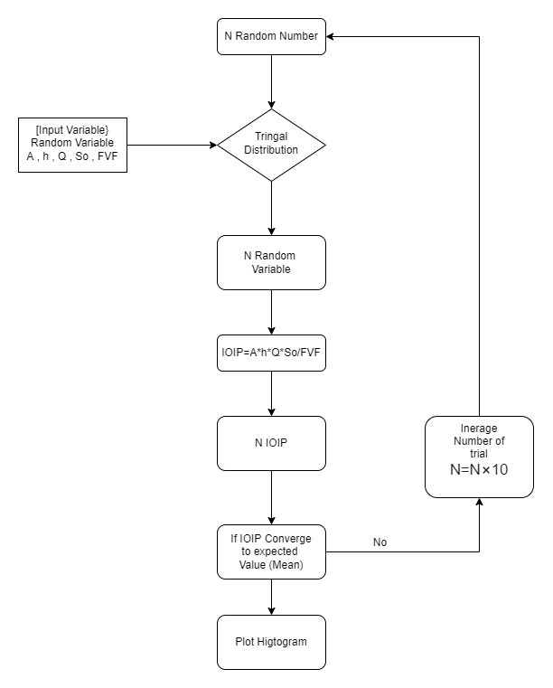

1. WORK FLOW DIAGRAM FOR THE RESERVOIR PERFORMANCE

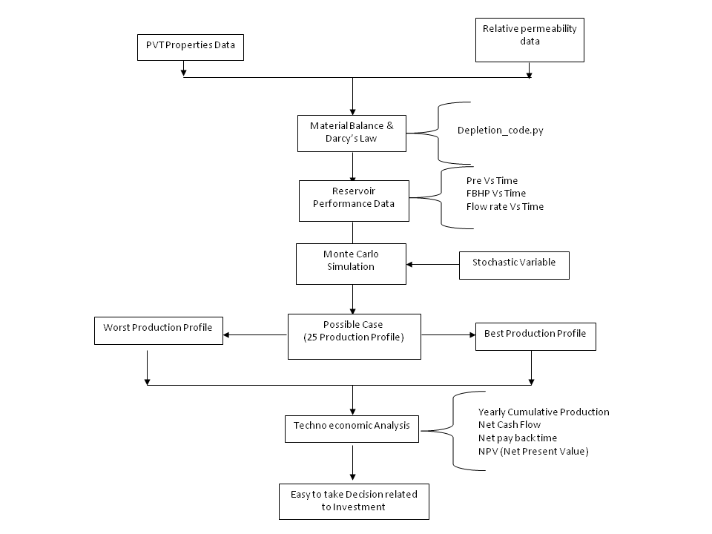

# 

# CHAPTER 2: RESERVOIR DEVELOPMENT

Reservoir development planning refers to strategies that begin with the exploration and appraisal well phase and end with the abandonment phase of a particular field to establish the course of action during the productive life of the asset. Figure 1.1 summarizes the phases of a reservoir development plan. The main objective of the complete cycle of a development plan is to maximize the asset value.

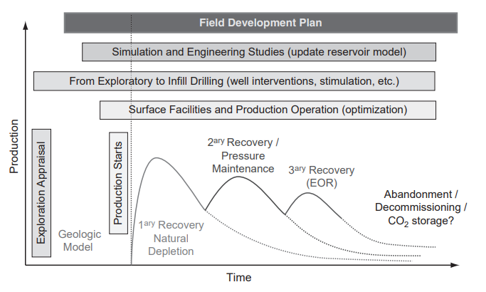

Figure 2.1 The main phases of a field development plan (Petrowiki, 2016)

Development strategies for new fields are based on data obtained from seismic surveys (which are not always acquired or readily accessible), exploratory wells, and other limited information sources such as fluid properties and reservoir analogues. Based on the information at hand, initial development plans are defined through simulation studies considering either a probabilistic or a stochastic approach to rank options using economic indicators, availability of injection fluids (i.e., water and/or gas), and oil recovery and risk, among other considerations.

Therefore, integrating the information from simulation studies helps to address the multiple and complex factors that influence oil recovery, as well as reservoir development decisions. As new information about the reservoir, its geology, and its degree of heterogeneity becomes available through drilling of new wells (i.e., development and infill wells) and production–injection history, the field can be developed in an optimal way.

There are many reason behind reservoir development plans (RDPs) change or must be adjusted or modified during the productive life of the field. Some of the reasons include the following:

• Lack of reservoir characterization and understanding of production mechanisms at the early stages of development (reduction of uncertainties with time)

• Poor production performance (e.g., production below expectations and early water breakthrough)

• Environmental constraints or drivers (e.g., CO2 storage, changes in legislation)

• Economics (e.g., low oil prices)

• New technologies (e.g., horizontal wells, multilaterals, and new recovery processes)

Managing the entire lifecycle of oil and gas fields is challenging for all E&P companies, from the early stages of asset exploration and appraisal through production activities and the eventual sale or abandonment of a field. How well are your technical teams equipped to help them understand their geological and engineering data, and the uncertainty in that data? The answer to this question is important in that it determines a company’s ability to accurately estimate reserves and forecast production. Economic decisions are made based on these forecasts therefore, if asset teams fail to properly understand the reservoir, they provide inaccurate reserve estimates and poor development strategies to decision-makers.

## Landmark Reservoir Development Lifecycle:

Landmark Reservoir Development Lifecycle is comprised of tools that help companies enhance their reservoir understanding and manage their asset’s lifecycle. Understand your asset’s potential and capture the uncertainty in that potential with earth modeling while pursuing the optimal economic outcome of developing your asset with reservoir simulation for evaluating the likely outcome of multiple development and operating plans.

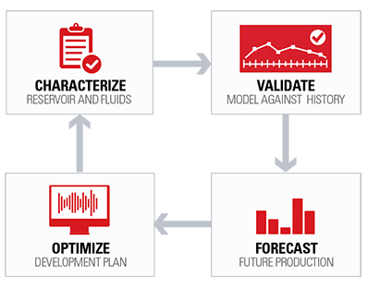

Figure 2.2 Reservoir Development lifecycle (Landmark, 2001)

### 2.1.1 Characterize Reservoir & Fluids:

In the exploration and appraisal lifecycle, if the asset economics are confirmed for development the process then moves to the reservoir development lifecycle where detailed analysis and asset modeling provides information needed for strategic development planning.  
  
 Asset teams gain understanding of their asset’s potential and uncertainty through reservoir characterization modeling, the process of integrating subsurface G&G data to create a static 3D earth model that provides critical information for the next phase of lifecycle activities. Residing on a single collaborative platform, Earth Modeling provides companies a way to seamlessly integrate all their G&G subsurface data to create a high resolution earth model in a cross-disciplinary effort while preserving data consistency. The resulting earth model offers a clear understanding of the reservoir geometry, and rock and fluid properties along with their uncertainty.  
  
 Once you have characterized the reservoir, reservoir simulation is used to predict the potential flow of oil, gas, and water through the reservoir. The impact of proposed operating plans on recovery efficiencies can be modeled, from which an optimized plan can be devised and validated. The reservoir simulation model combines the earth model, well locations, and completion design, along with well controls imposed or proposed during the simulated time period. Predictions of future production can be made more accurate by including surface pipelines and facility behavior in the simulation model, and determining their potential effects on the performance of the wells. With Software Suite, companies can create reservoir simulation models most representative of their assets behavior for field development strategies.

### 2.1.2 Validate Model against History:

Due to the uncertainty in the earth model properties, predictions based upon it will also be uncertain. To reduce earth model uncertainty, any historical production data that exists for the asset can be used in reservoir simulation to determine whether the field’s history is reproducible by the simulator based upon earth model properties. This calibration step, known as history matching, requires multiple simulation runs with properties chosen in accord with the distribution of properties in the earth model, and finding one or more sets of properties which lead to the observed well data being matched by the simulated wells. Companies can efficiently history match their reservoir simulation model against observed production data with Software.

### 2.1.3 Optimize Development Plan:

Most companies will seek an optimized development plan once the base case forecast has been completed, with the goal of increasing asset value. This process involves proposing one or more development options (e.g., water flooding or gas re-injection) which usually includes drilling additional wells. These development options are then modeled with multiple operating scenarios (different rates and pressures) which can be implemented in the field. Best practices dictate that development decisions should be made based on a comparison of forecasted behavior for various planned development options with the base case forecast. Production improvements, overall economics, field lifetime, and investment recovery time can all be considered, individually or in combination. With Software Suite companies have the ability to find the development plan which provides the greatest potential asset value.

### 2.1.4 Forecast Future Production:

Once the reservoir simulation model has been satisfactorily matched to production history, the process now turns to forecasting production and development planning. Forecasting is performed from the end of the field history through the expected operating life of the field, using the history-matched model to predict future behavior. The most frequent scenario is to forecast the base case in which no additional wells are drilled.

### 2.1.5 Uncertainty in Data:

Due to limited availability and quality of data, the complexity of the physics involved in predicting flow, and uncertainties in the modeling process, the reservoir model is always plagued by uncertainties. It is, therefore, important to analyze the input data in terms of quality, quantity, and complexities of different scales, review basic assumptions, appropriateness of the modeling workflow with reference to static and dynamic reservoir uncertainties, desired hardware and software tools to reposition the base case model with reasonable certainty for better project evaluation, risk analysis, and integrated decision making. Under these circumstances, it is necessary to achieve the right balance between short-term gains in production and optimizing long-term development. We propose a workfl ow that achieves this goal in a cost-effective way. This paper describes the workflow, and its effectiveness is demonstrated through an example.

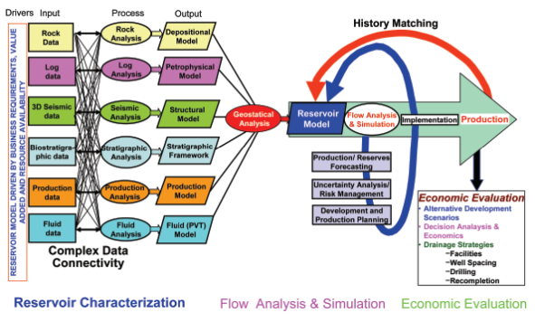

Figure 2.3 Reservoir Modeling process workflow (modology.org)

## 2.2 Integrated Reservoir Modeling Workflow:

The need for better decisions in field development has made it necessary to utilize multidisciplinary teams and integrate their functions/resources to maximize the economic value of the project. Figure 1 summarizes the process, shows the complex interrelation of various functions commonly implemented in a modeling effort and its iterative nature. Each process generates an output which is an input to the reservoir modeling or to other parts of the workflow. Implementation of many of these processes tends to be iterative as simple models evolve to more advanced models as additional data are collected during field development and as more understanding of a particular model is developed. The outputs from these processes are incorporated into a reservoir characterization model developed using geostatistical methods. The geologic framework forms the “static” portion of the reservoir model. Upscaling and application of flow analysis provides the “dynamic” part. Major sources of reservoir uncertainty at the early stage of development can be broadly grouped into four main categories:

* Geophysical uncertainties: Geophysical uncertainties about migration, time-to depth conversion, picking, fault positioning, and well ties.
* Geologic uncertainties: Geologic uncertainties about in-place hydrocarbon volume, sedimentary depositional environments, rock types and their heterogeneities, spatial distribution, and particle size.
* Petrophysical uncertainties: Petrophysical uncertainties about net reservoir thickness, Vshale, porosity, permeability, water saturation, and fl uid contact locations.
* Dynamic uncertainties:Dynamic uncertainties about absolute and relative permeability, fault transmissibilities, horizontal barriers, thermodynamics, injectivity, productivity indexes, and well skin.

There are no rules to systematically rank these uncertainties, but an incorrectly selected or neglected uncertainty may result in incorrect quantification of development-related risks. Therefore, all possibilities should be considered. To appropriately assess these uncertainties, we suggest a workflow that focuses on six major areas:

### 2.2.1 Uncertainty in OOIP Calculation:

Petrophysical interpretation identifies a consistent set of rock properties from the log and core data with the objective of developing flexible petrophysical models. Typical deliverables are net reservoir thickness, shale volume, porosity, permeability, water saturation and fluid contact locations. These data are usually provided without quantitative determination of their uncertainties.

A wide range of probability distribution functions (pdfs) are used and uncertainty on their mean value is introduced to fully cover the range of petrophysical uncertainties. In the case of limited well data, it is important to capture the realistic range of uncertainty for each petrophysical parameter. To avoid underestimation of uncertainty ranges, well-log petrophysical properties can be calibrated. When sufficient well data are available, Monte Carlo simulation can calculate petrophysical uncertainty. Monte Carlo modeling is flexible and quick, allowing different interpretation models to be built and quick testing of the results. However, Monte Carlo simulation requires many iterations for a stable and meaningful set of statistics. This can be time consuming and needs to be evaluated for the specific case.

This integrated petrophysical interpretation assesses the possible range of petrophysical parameters to select reasonable cut-off parameters for defining productive zones in the reservoir, to obtain probabilistic hydrocarbon initially in-place (HIIP) estimates, to understand and solve reservoir fl ow simulation problems, and to determine reservoir performance.

Quantification of the distribution of hydrocarbon-initially in place (HIIP): The hydrocarbon Volume in a reservoir can be expressed as:

Vhc = A*h* φ* (1-Sw) * B

(2.1)

Or

Vhc = GRV* N/G* φ* (1-Sw) * B

Where,

A = area of the reservoir filled with hydrocarbon,

h = reservoir thickness,

GRV = gross rock volume,

N/G = net to gross thickness,

φ = porosity,

Sw = water saturation,

B = hydrocarbon surface transformation factor (1/FVF),

Vhc = volume of hydrocarbon, and

FVF = formation volume factor.

After all parameters are determined, the volumetric equation can compute the distribution of HIIP. To avoid overestimates or underestimates of HIIP, it is important to include the dependency relationships between input parameters (e.g., area versus net pay, porosity versus water saturation) if any exist. The estimation of HIIP distribution combines reservoir geometrical, geologic and petrophysical uncertainties and uses reservoir geometry (structural/stratigraphic framework), facies distribution, rock types and porosity, net-to-gross, permeability and saturation). In the case of scarce data, it is necessary to define the range of uncertainties to obtain the probability distribution of HIIP.

Evaluating the impact of uncertainties on project economics and risks:

The production forecast obtained from reservoir simulation forms the basis for assessing project feasibility and business value, estimating the economic performance of various production strategies, and prioritizing them based on return on investment. The schedule of wells to be drilled, the pressure maintenance strategy, the investment schedule for the new pipelines and equipment facilities are a few of the important components of the forecasting scenario. Additionally, economic parameters, such as costs for drilling, laying new pipelines and investing in new equipment, along with pricing forecasts for oil and gas for revenue estimation, are needed for the evaluation of alternate development strategies.

The monetary value of a project can be normally determined by five factors: (1) the amount of hydrocarbon recoverable under a specific development scheme; (2) the rate at which these hydrocarbons can be produced: (3) the cost of producing hydrocarbons; (4) the price that the hydrocarbons will fetch at the market; and (5) the fiscal regime under which the hydrocarbons will be produced.

# CHAPTER 3: MONTE CARLO

Monte Carlo simulation is a computerized mathematical technique that allows people to account for risk in quantitative analysis and decision making. The technique is used by professionals in such widely disparate fields as finance, project management, energy, manufacturing, engineering, research and development, insurance, oil & gas, transportation, and the environment.

Monte Carlo simulation furnishes the decision-maker with a range of possible outcomes and the probabilities they will occur for any choice of action. It shows the extreme possibilities—the outcomes of going for broke and for the most conservative decision—along with all possible consequences for middle-of-the-road decisions.

The technique was first used by scientists working on the atom bomb; it was named for Monte Carlo, the Monaco resort town renowned for its casinos. Since its introduction in World War II, Monte Carlo simulation has been used to model a variety of physical and conceptual

Monte Carlo simulation performs risk analysis by building models of possible results by substituting a range of values—a probability distribution—for any factor that has inherent uncertainty. It then calculates results over and over, each time using a different set of random values from the probability functions. Depending upon the number of uncertainties and the ranges specified for them, a Monte Carlo simulation could involve thousands or tens of thousands of recalculations before it is complete. Monte Carlo simulation produces distributions of possible outcome values.

By using probability distributions, variables can have different probabilities of different outcomes occurring. Probability distributions are a much more realistic way of describing uncertainty in variables of a risk analysis.

## 

## 3.1 Monte Carlo Simulation Steps:

**Step 1:** Define all the variables. We must specify the measure of value of interest to us(e.g. NPV), and all the variable that affect the calculation of value.

**Step 2:** Define the variable relationships in the deterministic projection model. The relationship are the equation or other numerical calculation by which we make projection rated, net cash flow etc. that lead to the value calculation, e.g. NPV, of a drilling prospect. These relationships, or series of stepwise calculations, comprise the model or system we are trying to analyze.

**Step 3:** Sort the input variable into two groups. Those variables whose values are known with certainty or reasonable precision and can be represented as single point values. Significant unknowns will be represented as random variables for which exact values cannot be specified at the time of decision making.

**Step 4:** Define distributions for the random variables. Usually, the best available expert is assigned to judge each random variable.

**Step 5:** Perform the repetitive simulation trials so as to describe the distribution of value.

**Step 6:** Calculate expected value of the outcome value distribution. Usually this is EV NPV = EMV. Prepare graphical displays of the evaluation model and results.

# CHAPTER 4: APPLICATION OF MONTE CARLO SIMULATION IN OOIP DISTRIBUTION

**Oil in place (OIP)** (not to be confused with **original oil-in-place (OOIP)**) is a specialist term in petroleum geology that refers to the total oil content of an oil reservoir. As this quantity cannot be measured directly, it has to be estimated from other parameters measured prior to drilling or after production has begun.

(4.1)

Vhc = A*h* φ* (1-Sw) * B

Where,

A = area of the reservoir filled with hydrocarbon,

h = reservoir thickness, GRV = gross rock volume,

φ = porosity, Sw = water saturation,

B = hydrocarbon surface transformation factor (1/FVF),

Vhc = volume of hydrocarbon, and

FVF = formation volume factor

This is the volumetric method which is used to calculate the reserve at the initial stage. Here we take the Area of the Reservoir from the Seismic data. We take the Net pay thickness, porosity, saturation from the well log data. Here we take the oil formation volume factor from the PVT analysis.

Flow Diagram:



Yes

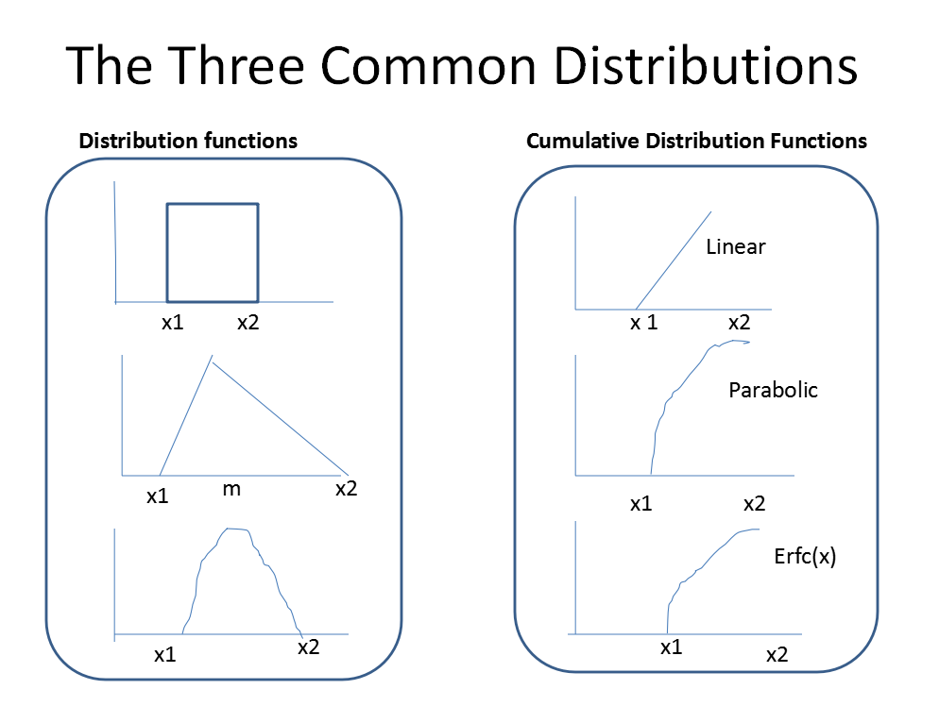

Figure 4.1 Common type of Distribution in Monte Carlo simulation (simulation, Scidirect.org)

Selection of Data Distribution depends on the surrounding nature field data. Even these things come after the Experience. Our Monte Carlo Program taking the random data which is lies between the X1 and X2.

Here X1 is minimum value

X2 is Maximum Value

X3 is Mean Value

For Triangle Distribution sampled variable is obtained as:

For

(4.2)

For

(4.3)

Here have made Python program to generate the Reserve Distribution. For that in program we have use the Random function to generate the N Random number. Now we have used triangular distribution for each stochastic variable to generate the random variable which lies between given ranges. We have put this variable in to Volume metric equation to generate N IOIP. Now here we have to analyze, whether our Value is converge to mean value or not. If yes then we get the right data, if not then we have to increase the number of the tria

# CHAPTER 5: APPLICATION OF MONTE CARLO IN DEPLETION DRIVE RESERVOIR

## 5.1 Reservoir Development Planning:

Here we have Depletion Drive Reservoir. Here Expansion of solution Gas and Expansion of the oil gives energy to transport crude oil from the Reservoir to the Well bore. At the Initial time we have Very Limited data to characterize the Reservoir. We have data, but it’s available in range.

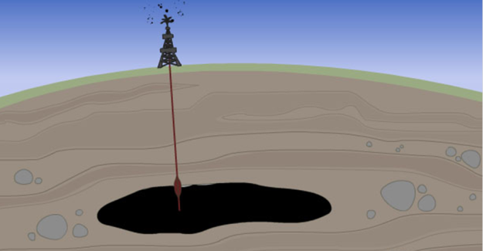

Uncertainty in Area, IOIP, KH etc

Figure 5.1 Uncertainty in Reservoir(petrowiki, 2009)

So at the initial time, there is high uncertainty in data like, Reservoir Area, IOIP, KH etc.

Input Data of Reservoir

30e+6, 15e+6, 20e+6 #Area: Max(x2), Min(x1), Mean(x3) (ft^2)

64e+6, 30e+6, 45e+6 #IOIP: Max, Min, Mean (STB)

800,300,550 #KH: Max, Min, Mean (mD-ft)

2000,1500,1750 #Qo: Max, Min, Mean(STB/day)

It’s become very difficult to decide whether we should do investment or not?

### 5.1.1 Other Reservoir Parameter:

Pi = 2500 Psi

Rw = 0.29 ft

S = 0

KH = 647

API = 44.2

T = 678 R

SG of Gas = 0.781

SG of Oil =0.604

Swi = 0.2

Soi = 0.8

Sgi = 0

There is huge investment require to take out the crude oil from the reservoir. So it’s become the problem for us to take the decision.

There are lot of question comes like

* What will be the worst case scenario?
* What will be the Maximum Production?
* How much amount of cumulative Production will get?
* What will be Net pay time?
* What will be the NPV?
* What will be the IRR? Etc.

So,

Here we have made the Python code program which can give the all the answer of the above question, Which help us to take the Decision whether should we go for the Investment or Not?

## 5.2 Pvt Properties:

To understand and predict the volumetric behavior of oil and gas reservoirs as a function of pressure, knowledge of the physical properties of reservoir fluids must be gained. These fluid properties are usually determined by laboratory experiments performed on samples of actual reservoir fluids. In the absence of experimentally measured properties, it is necessary for the petroleum engineer to determine the properties from empirically derived correlations for the following reservoir fluids:

• Natural gases

• Crude oil systems

• Reservoir water systems

### 5.2.1 The Properties Of Natural Gas:

A gas is defined as a homogeneous fluid of low viscosity and density that has no definite volume but expands to completely fill the vessel in which it is placed. Knowledge of pressure-volume-temperature (PVT) relationships and other physical and chemical properties of gases is essential for solving problems in natural gas reservoir engineering. These properties include:

• Apparent molecular weight, Ma

• Specific gravity, gg

• Compressibility factor, z

• Density, Rhog

• Specific volume, v

• Isothermal gas compressibility coefficient, cg

• Gas formation volume factor, Bg

• Gas expansion factor, Eg

• Viscosity, mg

The above gas properties may be obtained from direct laboratory measurements or by prediction from generalized mathematical expressions. This section reviews laws that describe the volumetric behavior of gases in terms of pressure and temperature and also documents the mathematical correlations that are widely used in determining the physical properties of natural gases.

#### 5.2.1.1 Gas Compressibility Factor:

In dealing with gases at a very low pressure, the ideal gas relationship is a convenient and generally satisfactory tool. At higher pressures, the use of the ideal gas equation-of-state may lead to errors as great as 500%, as compared to errors of 2–3% at atmospheric pressure.

Basically, the magnitude of deviations of real gases from the conditions of the ideal gas law increases with increasing pressure and temperature and varies widely with the composition of the gas. Real gases behave differently than ideal gases. The reason for this is that the perfect gas law was derived under the assumption that the volume of molecules is insignificant and that no molecular attraction or repulsion exists between them. This is not the case for real gases.

Numerous equations-of-state have been developed in the attempt to correlate the pressure-volume-temperature variables for real gases with experimental data. In order to express a more exact relationship between the variables p, V, and T, a correction factor called the *gas compressibility factor, gas deviation factor,* or simply the *z-factor,* must be introduced into Equation 2-1 to account for the departure of gases from ideality. The equation has the following form:

pV  znRT (5.1)

where the gas compressibility factor z is a dimensionless quantity and is defined as the ratio of the actual volume of n-moles of gas at T and p to the ideal volume of the same number of moles at the same T and p

(5.2)

Studies of the gas compressibility factors for natural gases of various compositions have shown that compressibility factors can be generalized with sufficient accuracies for most engineering purposes when they are expressed in terms of the following two dimensionless properties:

• Pseudo-reduced pressure

• Pseudo-reduced temperature

These dimensionless terms are defined by the following expressions:

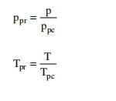

(5.3)

where p  system pressure, psia

ppr  pseudo-reduced pressure, dimensionless

T  system temperature, °R

Tpr  pseudo-reduced temperature, dimensionless

ppc, Tpc  pseudo-critical pressure and temperature, respectively, and

defined by the following relationships:

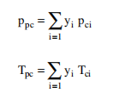

(5.4)

It should be pointed out that these pseudo-critical properties, i.e., Ppc and Tpc, do not represent the actual critical properties of the gas mixture. These pseudo properties are used as correlating parameters in generating gas properties.

Based on the concept of pseudo-reduced properties, Standing and Katz presented a generalized gas compressibility factor chart as shown in Figure. The chart represents compressibility factors of sweet natural gas as a function of ppr and Tpr. This chart is generally reliable for natural gas with minor amount of non hydrocarbons. It is one of the most widely accepted correlations in the oil and gas industry.

##### 5.2.1.1.1 Direct Calculation of the Compressibility Factor:

After four decades of existence, the Standing-Katz z-factor chart is still widely used as a practical source of natural gas compressibility factors. As a result, there has been an apparent need for a simple mathematical description of that chart. Several empirical correlations for calculating z-factors have been developed over the years. The following three empirical correlations are described below:

• Hall-Yarborough

• Dranchuk-Abu-Kassem

• Dranchuk-Purvis-Robinson

##### 5.2.1.1.2 The Hall-Yarborough Method:

Hall and Yarborough (1973) presented an equation-of-state that accurately represents the Standing and Katz z-factor chart. The proposed expression is based on the Starling-Carnahan equation-of-state. The coefficients of the correlation were determined by fitting them to data taken from the Standing and Katz z-factor chart. Hall and Yarborough proposed the following mathematical form

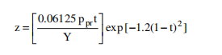

(5.5)

where Ppr  pseudo-reduced pressure

t  reciprocal of the pseudo-reduced temperature, i.e., Tpc/T

Y  the reduced density that can be obtained as the solution of the following equation:

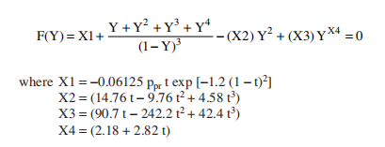

(5.6)

where X1 = -0.06125*Ppr*t *exp [-1.2*(1-t)2]

X2 = 14.76*t – 9.76*t2 + 4.58* t3

X3 = 90.7*t – 242.2*t2 + 42.4 * t3

X4 = 2.18 + 2.82*t

Equation is a nonlinear equation and can be conveniently solved for the reduced density Y by using the Newton-Raphson iteration technique. The computational procedure of solving Equation 2-37 at any specified pseudo-reduced pressure ppr and temperature Tpr is summarized in the following steps:

*Step 1.* Make an initial guess of the unknown parameter, Yk, where k is an iteration counter. An appropriate initial guess of Y is given by the following relationship:

Yk = 0.0125 *Ppr* t* exp [−1.2 (1 − t)^2] (5.7)

*Step 2.* Substitute this initial value in Equation 5.7 and evaluate the nonlinear function. Unless the correct value of Y has been initially selected,

*Step 3.* A new improved estimate of Y, i.e., Yk+1, is calculated from the following expression:

Where f’(Y(k)) is obtained by evaluating the derivation of equation (5.7) at Y(k), or:

(5.8)

*Step 4.* Steps 2–3 are repeated n times, until the error, i.e., abs(Yk -Yk+1), becomes smaller than a preset tolerance,

*Step 5.* The correct value of Y is then used to evaluate Equation 5.8 for the compressibility factor.

Hall and Yarborough pointed out that the method is not recommended for application if the pseudo-reduced temperature is less than one.

### 

Figure 5.2 Z-factor vs Pressure

Table 5.1 Z factor data

|  |  |
| --- | --- |
| Z-Factor | Pressure(Psi) |
| 0.8622125 | 2498 |
| 0.8622148 | 2497 |
| 0.8622172 | 2496 |
| 0.8622196 | 2495 |
| 0.862222 | 2494 |
| 0.8624499 | 2436 |
| 0.8624553 | 2435 |
| 0.8624607 | 2434 |
| 0.8624663 | 2433 |
| 0.8624718 | 2432 |
| 0.8626341 | 2406 |
| 0.862641 | 2405 |
| 0.862648 | 2404 |
| 0.862655 | 2403 |
| 0.8626621 | 2402 |

### 

|  |  |
| --- | --- |
| Z-Factor | Pressure(Psi) |
| 0.8634367 | 2318 |
| 0.8634481 | 2317 |
| 0.8634595 | 2316 |
| 0.863471 | 2315 |
| 0.8634825 | 2314 |
| 0.8658031 | 2163 |
| 0.8658224 | 2162 |
| 0.8658416 | 2161 |
| 0.8658609 | 2160 |
| 0.8658803 | 2159 |
| 0.8710504 | 1949 |
| 0.8710802 | 1948 |
| 0.8711101 | 1947 |
| 0.87114 | 1946 |
| 0.87117 | 1945 |

#### 5.2.1.2 Gas Formation Volume Factor:

The gas formation volume factor is used to relate the volume of gas, as measured at reservoir conditions, to the volume of the gas as measured at standard conditions, i.e., 60°F and 14.7 psia. This gas property is then defined as the actual volume occupied by a certain amount of gas at a specified pressure and temperature, divided by the volume occupied by the same amount of gas at standard conditions. In an equation form, the relationship is expressed a

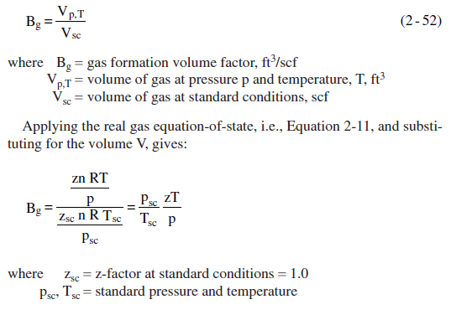

(5.9)

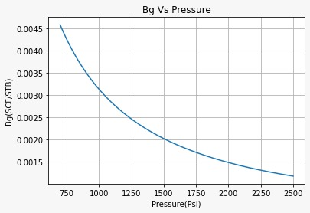

Figure 5.3 Gas formation volume factor(Bg) vs Pressure

**Table 5.2 Bg factor data**

|  |  |
| --- | --- |
| Pressure(Psi) | Bg |
| 2498 | 0.001178 |
| 2497 | 0.001179 |
| 2496 | 0.001179 |
| 2495 | 0.00118 |
| 2442 | 0.001206 |
| 2441 | 0.001206 |
| 2440 | 0.001207 |
| 2439 | 0.001207 |
| 2400 | 0.001227 |
| 2399 | 0.001228 |
| 2393 | 0.001231 |
| 2392 | 0.001231 |
| 2391 | 0.001232 |
| 2390 | 0.001232 |
| 2389 | 0.001233 |

|  |  |
| --- | --- |
| Pressure(Psi) | Bg |
| 2398 | 0.001228 |
| 2397 | 0.001229 |
| 2357 | 0.00125 |
| 2356 | 0.001251 |
| 2355 | 0.001251 |
| 2354 | 0.001252 |
| 2042 | 0.001452 |
| 2041 | 0.001453 |
| 2040 | 0.001453 |
| 2039 | 0.001454 |
| 1960 | 0.001517 |
| 1959 | 0.001517 |
| 1958 | 0.001518 |
| 1957 | 0.001519 |
| 1956 | 0.00152 |

#### 5.2.1.3 Gas Viscosity:

The viscosity of a fluid is a measure of the internal fluid friction (resis- tance) to flow. If the friction between layers of the fluid is small, i.e., low viscosity, an applied shearing force will result in a large velocity gradi- ent. As the viscosity increases, each fluid layer exerts a larger frictional drag on the adjacent layers and velocity gradient decreases.

The viscosity of a fluid is generally defined as the ratio of the shear force per unit area to the local velocity gradient. Viscosities are expressed in terms of poises, centipoise, or micropoises. One poise equals a viscosity of 1 dyne-sec/cm2 and can be converted to other field units by the following relationships:

1 poise  100 centipoises

 1  106 micropoises

 6.72  102 lb mass/ft-sec

The gas viscosity is not commonly measured in the laboratory because it can be estimated precisely from empirical correlations. Like all intensive properties, viscosity of a natural gas is completely described by the following function:

g  (p,T,yi) (5.10)

where g  the viscosity of the gas phase. The above relationship simply states that the viscosity is a function of pressure, temperature, and com- position. Many of the widely used gas viscosity correlations may be viewed as modifications of that expression.

##### 5.2.1.3.1 The Lee-Gonzalez-Eakin Method

Lee, Gonzalez, and Eakin (1966) presented a semi-empirical relation- ship for calculating the viscosity of natural gases. The authors expressed the gas viscosity in terms of the reservoir temperature, gas density, and the molecular weight of the gas. Their proposed equation is given by:

#### 

(5.11)

 g  gas density at reservoir pressure and temperature, lb/ft3

T  reservoir temperature, °R

Ma  apparent molecular weight of the gas mixture

The proposed correlation can predict viscosity values with a standard deviation of 2.7% and a maximum deviation of 8.99%. The correlation is less accurate for gases with higher specific gravities. The authors pointed out that the method cannot be used for sour gases.

Charts And Data

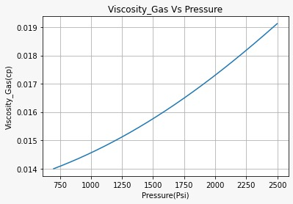

Figure 5.4 Gas viscosity vs Pressure

Table 5.3 Gas Viscosity Data

|  |  |
| --- | --- |
| Pressure(Psi) | Mug(cP) |
| 1690 | 0.016310816 |
| 1680 | 0.016280882 |
| 1670 | 0.016251078 |
| 1660 | 0.016221405 |
| 1650 | 0.016191861 |
| 1640 | 0.016162449 |
| 1120 | 0.014816969 |
| 1110 | 0.014794671 |
| 1100 | 0.014772508 |
| 1090 | 0.01475048 |
| 1080 | 0.014728588 |
| 1070 | 0.01470683 |
| 1060 | 0.014685208 |
| 430 | 0.013596424 |
| 420 | 0.013583584 |

|  |  |
| --- | --- |
| Pressure(Psi) | Mug(cP) |
| 2230 | 0.018109294 |
| 2220 | 0.018072978 |
| 2210 | 0.018036765 |
| 2200 | 0.018000655 |
| 2190 | 0.017964651 |
| 2180 | 0.017928752 |
| 2010 | 0.017335195 |
| 2000 | 0.017301299 |
| 1990 | 0.01726752 |
| 1980 | 0.017233858 |
| 1970 | 0.017200313 |
| 1960 | 0.017166888 |
| 1720 | 0.016401393 |
| 1710 | 0.016371072 |
| 1700 | 0.016340879 |

#### 5.2.1.4 Gas Solubility:

The gas solubility Rs is defined as the number of standard cubic feet of gas which will dissolve in one stock-tank barrel of crude oil at certain pressure and temperature. The solubility of a natural gas in a crude oil is a strong function of the pressure, temperature, API gravity, and gas gravity.

For a particular gas and crude oil to exist at a constant temperature, the solubility increases with pressure until the saturation pressure is reached. At the saturation pressure (bubble-point pressure) all the available gases are dissolved in the oil and the gas solubility reaches its maximum value. Rather than measuring the amount of gas that will dissolve in a given stock-tank crude oil as the pressure is increased, it is customary to deter- mine the amount of gas that will come out of a sample of reservoir crude oil as pressure decreases.

A typical gas solubility curve, as a function of pressure for an under- saturated crude oil, is shown in Figure 2-7. As the pressure is reduced from the initial reservoir pressure pi, to the bubble-point pressure pb, no gas evolves from the oil and consequently the gas solubility remains con- stant at its maximum value of Rsb. Below the bubble-point pressure, the solution gas is liberated and the value of Rs decreases with pressure. The following five empirical correlations for estimating the gas solubility are given below:

* Standing’s correlation
* The Petrosky-Farshad correlation

##### 5.2.1.4.1 Standing’s Correlation:

Standing (1947) proposed a graphical correlation for determining the gas solubility as a function of pressure, gas specific gravity, API gravity, and system temperature. The correlation was developed from a total of 105 experimentally determined data points on 22 hydrocarbon mixtures from California crude oils and natural gases. The proposed correlation has an average error of 4.8%. Standing (1981) expressed his proposed graphi- cal correlation in the following more convenient mathematical form:

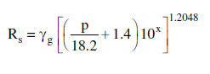

(5.12)

where T  temperature, °R

p  system pressure, psia

g  solution gas specific gravity

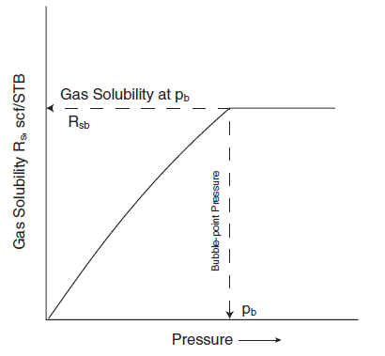

Figure 5.5 Ideal graph of Gas Solubility vs Pressure (Tarek Ahmed new edition)

It should be noted that Standing’s equation is valid for applications at and below the bubble-point pressure of the crude oil.

##### 5.2.1.4.2 The Petrosky-Farshad Correlation:

Petrosky and Farshad (1993) used a nonlinear multiple regression soft- ware to develop a gas solubility correlation. The authors constructed a PVT database from 81 laboratory analyses from the Gulf of Mexico crude oil system. Petrosky and Farshad proposed the following expression:

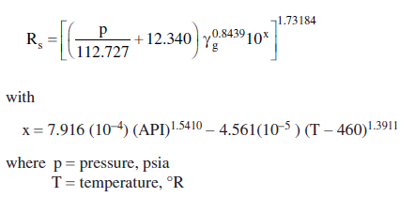

(5.13)

Data and Chart:

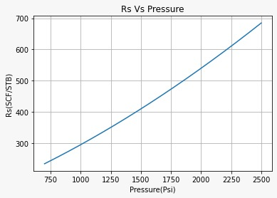

Figure 5.6 Gas Solubility vs Pressure

Table 5.4 Gas Solubility Data

|  |  |
| --- | --- |
| Pressure(Psi) | Rs(SCF/STB) |
| 1690 | 457.4042884 |
| 1680 | 454.8363013 |
| 1670 | 452.2744265 |
| 1660 | 449.7186693 |
| 1650 | 447.1690352 |
| 1640 | 444.6255294 |
| 1120 | 320.9502869 |
| 1110 | 318.7399605 |
| 1100 | 316.5360924 |
| 1090 | 314.3386894 |
| 1080 | 312.1477586 |
| 1070 | 309.9633071 |
| 1060 | 307.7853417 |
| 430 | 183.9874594 |
| 420 | 182.2412358 |

|  |  |
| --- | --- |
| Pressure(Psi) | Rs(SCF/STB) |
| 2230 | 605.0121975 |
| 2220 | 602.1215307 |
| 2210 | 599.2367164 |
| 2200 | 596.3577589 |
| 2190 | 593.4846627 |
| 2180 | 590.6174321 |
| 2010 | 542.7762736 |
| 2000 | 540.0153918 |
| 1990 | 537.2604619 |
| 1980 | 534.5114888 |
| 1970 | 531.768477 |
| 1960 | 529.0314315 |
| 1720 | 465.1448704 |
| 1710 | 462.5585783 |
| 1700 | 459.9783825 |

#### 5.2.1.5 Oil Formation Volume Factor:

The oil formation volume factor, Bo, is defined as the ratio of the vol- ume of oil (plus the gas in solution) at the prevailing reservoir tempera- ture and pressure to the volume of oil at standard conditions. Bo is always greater than or equal to unity. The oil formation volume factor can be expressed mathematically as:

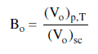

(5.14)

where Bo  oil formation volume factor, bbl/STB

(Vo)p,T  volume of oil under reservoir pressure p and temperature T, bbl

(Vo)sc  volume of oil is measured under standard conditions, STB

A typical oil formation factor curve, as a function of pressure for an undersaturated crude oil (pi > pb), is shown in Figure 2-8. As the pressure is reduced below the initial reservoir pressure pi, the oil volume increases due to the oil expansion. This behavior results in an increase in the oil for- mation volume factor and will continue until the bubble-point pressure is reached. At pb, the oil reaches its maximum expansion and consequently attains a maximum value of Bob for the oil formation volume factor. As the pressure is reduced below pb, volume of the oil and Bo are decreased as the solution gas is liberated. When the pressure is reduced to atmospheric pressure and the temperature to 60°F, the value of Bo is equal to one.

Most of the published empirical Bo correlations utilize the following generalized relationship:

Bo  f (Rs,  g,  o, T)

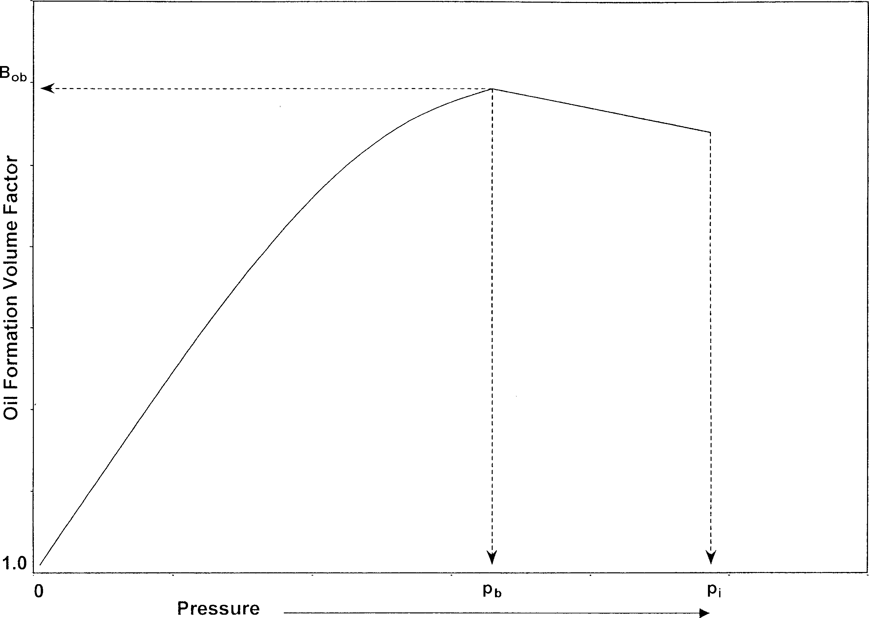

Figure 5.7 Ideal graph of oil formation volume factor vs Pressure (Tarek Ahmed new edition)

##### 5.2.1.5.1 Standing’s Correlation:

Standing (1947) presented a graphical correlation for estimating the oil formation volume factor with the gas solubility, gas gravity, oil gravity, and reservoir temperature as the correlating parameters. This graphical correlation originated from examining a total of 105 experimental data points on 22 different California hydrocarbon systems. An average error of 1.2% was reported for the correlation.

Standing (1981) showed that the oil formation volume factor can be expressed more conveniently in a mathematical form by the following equation:

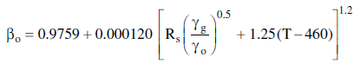

(5.15)

where T  temperature, °R

o  specific gravity of the stock-tank oil

g  specific gravity of the solution gas

Chart and Data:

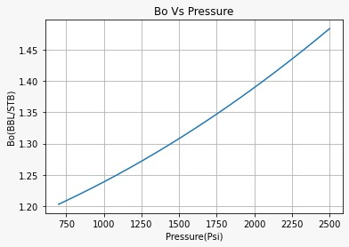

Figure 5.8 Bo vs pressure

Figure **Error! Use the Home tab to apply 0 to the text that you want to appear here.**‑15.8 oil formation volume factor vs Pressure

Table 5.5 Oil Formation Volume Factor Data

Table 5.5 Oil Formation Volume factor

|  |  |
| --- | --- |
| Pressure(Psi) | Bo(BBL/STB) |
| 1690 | 1.293276308 |
| 1680 | 1.291957823 |
| 1670 | 1.290643388 |
| 1660 | 1.289333004 |
| 1650 | 1.288026668 |
| 1640 | 1.286724379 |
| 1120 | 1.224551061 |
| 1110 | 1.223461462 |
| 1100 | 1.222375842 |
| 1090 | 1.2212942 |
| 1080 | 1.220216534 |
| 1070 | 1.219142843 |
| 1060 | 1.218073126 |
| 430 | 1.158641358 |
| 420 | 1.15782362 |

|  |  |
| --- | --- |
| Pressure(Psi) | Bo(BBL/STB) |
| 2230 | 1.370524626 |
| 2220 | 1.368985558 |
| 2210 | 1.367450606 |
| 2200 | 1.365919769 |
| 2190 | 1.364393047 |
| 2180 | 1.362870438 |
| 2010 | 1.337614251 |
| 2000 | 1.336165476 |
| 1990 | 1.334720792 |
| 1980 | 1.333280197 |
| 1970 | 1.33184369 |
| 1960 | 1.33041127 |
| 1720 | 1.297256083 |
| 1710 | 1.295925437 |
| 1700 | 1.294598846 |

#### 5.2.1.6 Crude Oil Viscosity:

Crude oil viscosity is an important physical property that controls and influences the flow of oil through porous media and pipes. The viscosity, in general, is defined as the internal resistance of the fluid to flow.

The oil viscosity is a strong function of the temperature, pressure, oil gravity, gas gravity, and gas solubility. Whenever possible, oil viscosity should be determined by laboratory measurements at reservoir tempera- ture and pressure. The viscosity is usually reported in standard PVT analyses. If such laboratory data are not available, engineers may refer to published correlations, which usually vary in complexity and accuracy depending upon the available data on the crude oil.

According to the pressure, the viscosity of crude oils can be classified into three categories:

**Dead-Oil Viscosity**: The dead-oil viscosity is defined as the viscosity of crude oil at atmospheric pressure (no gas in solution) and system temperature.

**Saturated-Oil Viscosity**: The saturated (bubble-point)-oil viscosity is defined as the viscosity of the crude oil at the bubble-point pressure and reservoir temperature

**Undersaturated-Oil Viscosity:** The undersaturated-oil viscosity is defined as the viscosity of the crude oil at a pressure above the bubble-point and reservoir temperature.

##### 5.2.1.6.1 Beal’s Correlation:

From a total of 753 values for dead-oil viscosity at and above 100°F, Beal (1946) developed a graphical correlation for determining the viscos- ity of the dead oil as a function of temperature and the API gravity of the crude. Standing (1981) expressed the proposed graphical correlation in a mathematical relationship as follows:

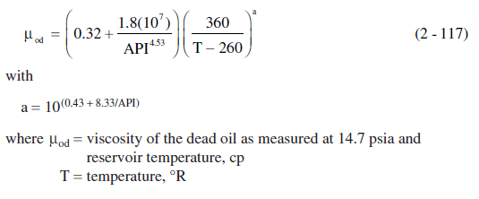

(5.16)

Table 5.6 Oil Viscosity Data

|  |  |
| --- | --- |
| Pressure(Psi) | Muo(cP) |
| 1690 | 0.208753592 |
| 1680 | 0.209325522 |
| 1670 | 0.2099022 |
| 1660 | 0.210483695 |
| 1650 | 0.211070072 |
| 1640 | 0.211661401 |
| 1120 | 0.251586189 |
| 1110 | 0.252592864 |
| 1100 | 0.253611824 |
| 1090 | 0.254643322 |
| 1080 | 0.255687619 |
| 1070 | 0.256744983 |
| 1060 | 0.257815691 |
| 430 | 0.375906008 |
| 420 | 0.379344302 |

|  |  |
| --- | --- |
| Pressure(Psi) | Muo(cP) |
| 2230 | 0.183481454 |
| 2220 | 0.183868903 |
| 2210 | 0.184258824 |
| 2200 | 0.184651241 |
| 2190 | 0.185046183 |
| 2180 | 0.185443676 |
| 2010 | 0.192620054 |
| 2000 | 0.193068659 |
| 1990 | 0.193520424 |
| 1980 | 0.193975385 |
| 1970 | 0.194433582 |
| 1960 | 0.194895052 |
| 1720 | 0.207065651 |
| 1710 | 0.20762372 |
| 1700 | 0.208186346 |

## 5.3 Relative permeability:

Numerous laboratory studies have concluded that the effective permeability of any reservoir fluid is a function of the reservoir fluid saturation and the wetting characteristics of the formation. It becomes necessary, therefore, to specify the fluid saturation when stating the effective perm ability of any particular fluid in a given porous medium. Just as k is the accepted universal symbol for the absolute permeability, ko, kg, and kw are the accepted symbols for the effective permeability to oil, gas, and water, respectively. The saturations, i.e., So, Sg, and Sw, must be specified to completely define the conditions at which a given effective permeabil- ity exists.

Effective permeability are normally measured directly in the laboratory on small core plugs. Owing to many possible combinations of saturation for a single medium, however, laboratory data are usually summarized and reported as relative permeability.

The absolute permeability is a property of the porous medium and is a measure of the capacity of the medium to transmit fluids. When two or more fluids flow at the same time, the relative permeability of each phase at a specific saturation is the ratio of the effective permeability of the phase to the absolute permeability, or:

kro

krg

(5.17)

krw

where kro = relative permeability of oil

krg = relative permeability of oil

krw= relative permeability of oil

k= absolute permeability

ko= effective permeability to oil for a given oil saturation

kw= effective permeability to oil for a given gas saturation

kg= effective permeability to oil for a given water saturation

For example, if the absolute permeability k of a rock is 200 md and the effective permeability ko of the rock at an oil saturation of 80 percent is 60 md, the relative permeability kro is 0.30 at So  0.80.

Since the effective permeabilities may range from zero to k, the rela- tive permeabilities may have any value between zero and one, or:

0 < krw, kro, krg < 1.0

It should be pointed out that when three phases are present the sum of the relative permeabilities (kro, krg, krw) is both variable and always less than or equal to unity. An appreciation of this observation and of its physical causes is a prerequisite to a more detailed discussion of two- and three-phase relative permeability relationships.,It has become a common practice to refer to the relative permeability curve for the non-wetting phase as knw and the relative permeability for the wetting phase as kw.

### 5.3.1 Two-phase Relative Permeability:

When a wetting and a nonwetting phase flow together in a reservoir rock, each phase follows separate and distinct paths. The distribution of the two phases according to their wetting characteristics results in characteristic wetting and nonwetting phase relative permeabilities. Since the wetting phase occupies the smaller pore openings at small saturations, and these pore openings do not contribute materially to flow, it follows that the presence of a small wetting phase saturation will affect the nonwetting phase permeability only to a limited extent. Since the nonwetting phase occupies the central or larger pore openings which contribute materially to fluid flow through the reservoir, however, a small nonwetting phase saturation will drastically reduce the wetting phase permeability.

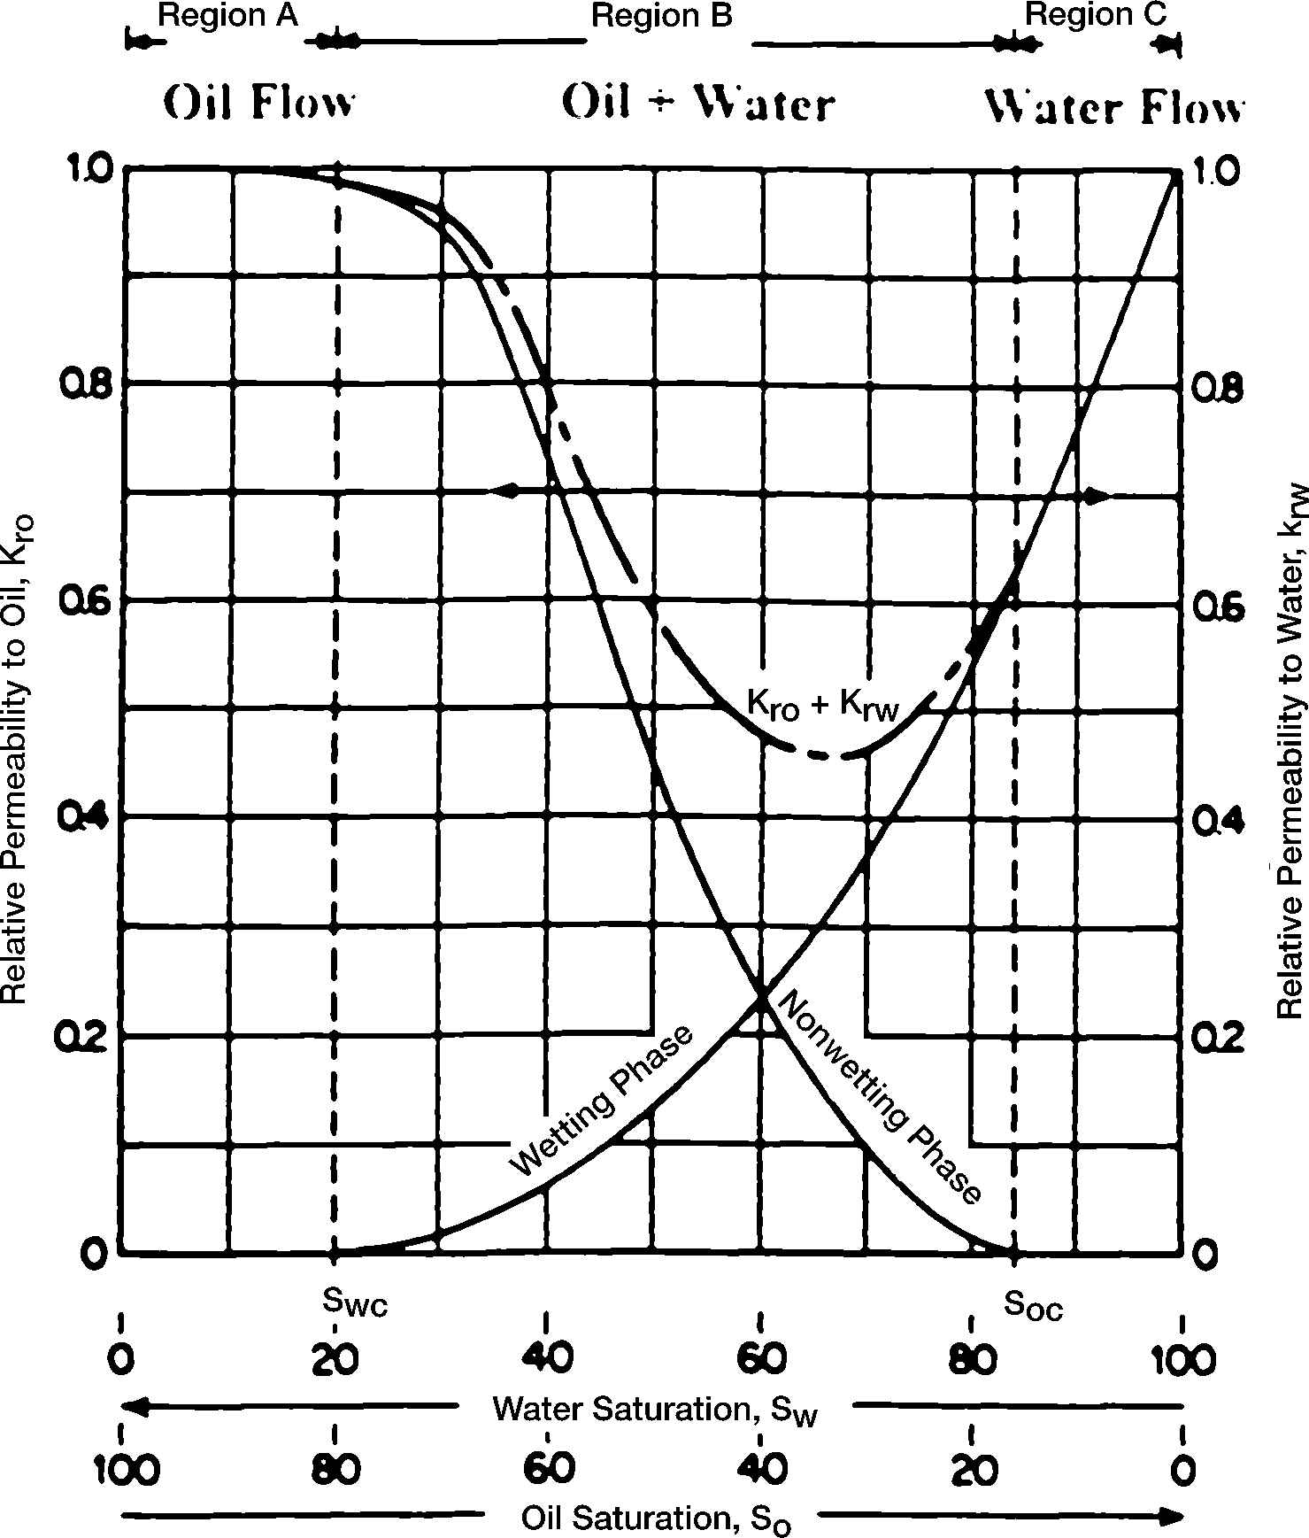Figure 5-1 presents a typical set of relative permeability curves for a water-oil system with the water being considered the wetting phase. Figure 5-1 shows the following four distinct and signific ant points:

Figure 5.9 Oil & Water Relative permeability vs Saturation of water (Tarek Ahmed new edition)

##### Point 1

Point 1 on the wetting phase relative permeability shows that a small saturation of the nonwetting phase will drastically reduce the relative permeability of the wetting phase. The reason for this is that the non- wetting phase occupies the larger pore spaces, and it is in these large pore spaces that flow occurs with the least difficulty.

##### Point 2

Point 2 on the nonwetting phase relative permeability curve shows that the nonwetting phase begins to flow at the relatively low saturation of the nonwetting phase. The saturation of the oil at this point is called *critical oil saturation* Soc.

##### Point 3

Point 3 on the wetting phase relative permeability curve shows that the wetting phase will cease to flow at a relatively large saturation. This is because the wetting phase preferentially occupies the smaller pore spaces, where capillary forces are the greatest. The saturation of the water at this point is referred to as the *irreducible water saturation* Swir or *connate water saturation* Swi—both terms are used interchangeably.

##### Point 4

Point 4 on the nonwetting phase relative permeability curve shows that, at the lower saturations of the wetting phase, changes in the wet- ting phase saturation have only a small effect on the magnitude of the nonwetting phase relative permeability curve. The reason for the phenomenon at Point 4 is that at the low saturations the wetting phase fluid occupies the small pore spaces which do not contribute materially to flow, and therefore changing the saturation in these small pore spaces has a relatively small effect on the flow of the nonwetting phase.

This process could have been visualized in reverse just as well. It should be noted that this example portrays oil as nonwetting and water as wetting. The curve shapes shown are typical for wetting and nonwetting phases and may be mentally reversed to visualize the behavior of an oil-wet system. Note also that the total permeability to both phases, krw  kro, is less than 1, in regions B and C.

The above discussion may be also applied to gas-oil relative permeability data, as can be seen for a typical set of data in Figure 5-2. Note that this might be termed gas-liquid relative permeability since it is plotted versus the liquid saturation. This is typical of gas-oil relative permeability data in the presence of connate water. Since the connate (irreducible) water normally occupies the smallest pores in the presence of oil and gas, it appears to make little difference whether water or oil that would also be immobile in these small pores occupies these pores. Consequently, in applying the gas-oil relative permeability data to a reservoir, the total liquid saturation is normally used as a basis for evaluating the relative permeability to the gas and oil.

Note that the relative permeability curve representing oil changes completely from the shape of the relative permeability curve for oil in the water-oil system. In the water-oil system, as noted previously, oil is nor- mally the nonwetting phase, whereas in the presence of gas the oil is the wetting phase. Consequently, in the presence of water only, the oil rela- tive permeability curve takes on an S shape whereas in the presence of gas the oil relative-permeability curve takes on the shape of the wetting phase, or is concave upward. Note further that the critical gas saturation Sgc is generally very small.

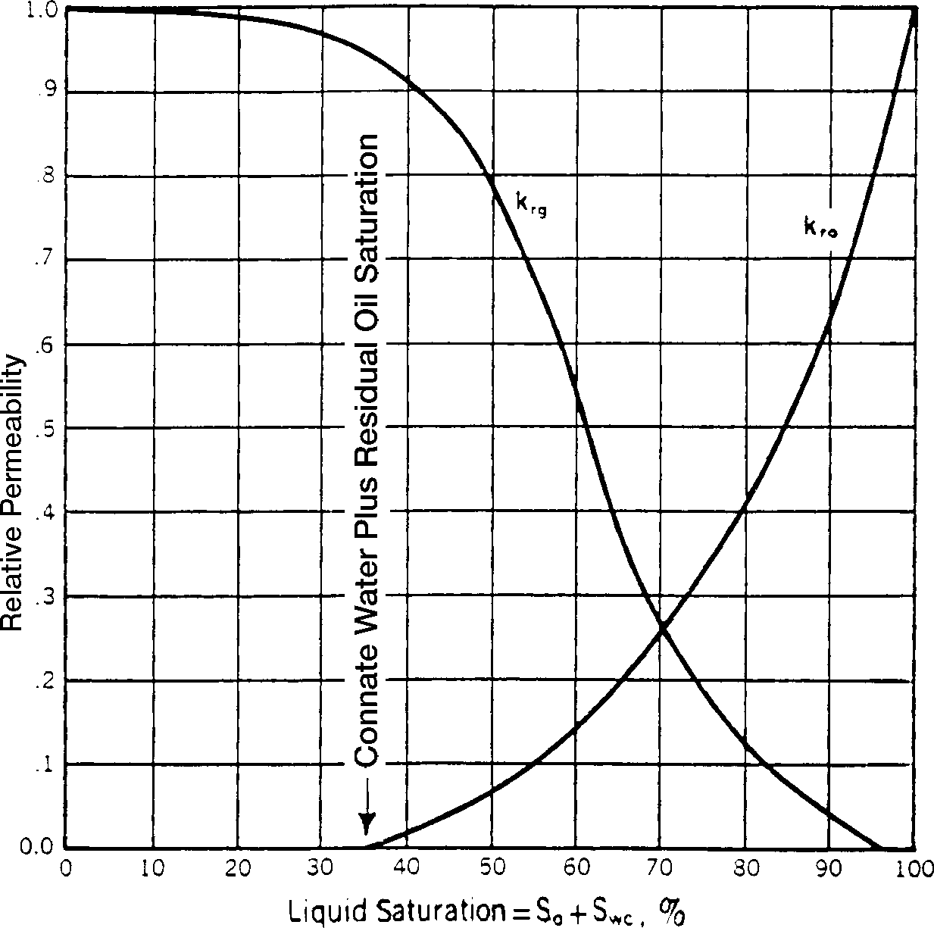

Figure 5.10 Gas-oil relative permeability curves (Tarek Ahmed new edition)

Another important phenomenon associated with fluid flow through porous media is the concept of residual saturations. As when one immiscible fluid is displacing another, it is impossible to reduce the saturation of the displaced fluid to zero. At some small saturation, which is presumed to be the saturation at which the displaced phase ceases to be con tinuous, flow of the displaced phase will cease. This saturation is often referred to as the *residual* saturation. This is an important concept as it determines the maximum recovery from the reservoir. Conversely, a fluid must develop a certain minimum saturation before the phase will begin to flow. This is evident from an examination of the relative permeability curves shown in Figure 5-1. The saturation at which a fluid will just begin to flow is called the *critical* saturation.

Theoretically, the critical saturation and the residual saturation should be exactly equal for any fluid; however, they are not identical. **Critical saturation is measured in the direction of increasing saturation, while irreducible saturation is measured in the direction of reducing saturation.** Thus, the saturation histories of the two measurements are different.

As was discussed for capillary-pressure data, there is also a saturation history effect for relative permeability. The effect of saturation history on relative permeability is illustrated in Figure 5-3. If the rock sample is initially saturated with the wetting phase (e.g., water) and relative-permeability data are obtained by decreasing the wetting-phase saturation while flowing nonwetting fluid (e.g., oil) in the core, the process is classified as *drainage* or *desaturation.*

If the data are obtained by increasing the saturation of the wetting phase, the process is termed *imbibition* or *resaturation.* The nomenclature is consistent with that used in connection with capillary pressure. This difference in permeability when changing the saturation history is called *hysteresis.* Since relative permeability measurements are subject to hysteresis, it is important to duplicate, in the laboratory, the saturation history of the reservoir.

#### 5.3.1.1 COREY’S METHOD:

Corey (1954) proposed a simple mathematical expression for generating the relative permeability data of the gas-oil system. The approximation is good for drainage processes, i.e., gas-displacing oil.

Sw* = Sg/(1-Swc)  
Kro = (1- S*g)4

(5.18)

Krg = (S*g)(2-S*g)

where = the effective gas saturation

Data and Chart:

Table 5.7 Relative Permeability of the Oil and gas

|  |  |  |  |
| --- | --- | --- | --- |
| So | Sg | Kro | Krg |
| 0.65 | 0.1 | 0.586182 | 0.003662 |
| 0.55 | 0.2 | 0.316406 | 0.027344 |
| 0.45 | 0.3 | 0.152588 | 0.085693 |
| 0.35 | 0.4 | 0.0625 | 0.1875 |
| 0.25 | 0.5 | 0.019775 | 0.335693 |
| 0.15 | 0.6 | 0.003906 | 0.527344 |

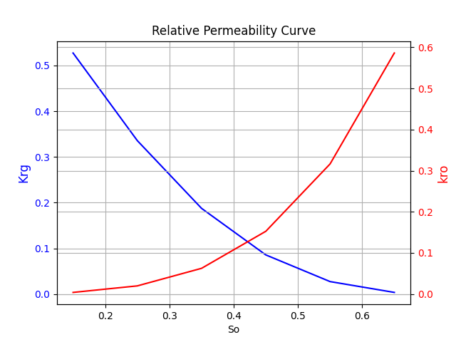

Figure 5.10 Gas-oil relative permeability curves

## 5.4 Primary Recovery:

For a proper understanding of reservoir behavior and predicting future performance, it is necessary to have knowledge of the driving mechanisms that control the behavior of fluids within reservoirs. The overall performance of oil reservoirs is largely determined by the nature of the energy, i.e., driving mechanism, available for moving the oil to the wellbore. There are basically six driving mechanisms that provide the natural energy necessary for oil recovery:

* Rock and liquid expansion drive
* Depletion drive
* Gas cap drive
* Water drive
* Gravity drainage drive
* Combination drive

### 5.4.1 The Depletion drive Mechanism:

This driving form may also be referred to by the following various terms:

* Solution gas drive
* Dissolved gas drive
* Internal gas drive

In this type of reservoir, the principal source of energy is a result of gas liberation from the crude oil and the subsequent expansion of the solution gas as the reservoir pressure is reduced. As pressure falls below the bubble-point pressure, gas bubbles are liberated within the microscopic pore spaces.

* **Reservoir Pressure**: The reservoir pressure declines rapidly and continuously. This reservoir pressure behavior is attributed to the fact that no extraneous fluids or gas caps are available to provide a replacement of the gas and oil withdrawals.
* **Water Production:** The absence of a water drive means there will be little or no water production with the oil during the entire producing life of the reservoir.
* **Gas-oil ratio:** A depletion-drive reservoir is characterized by a rapidly increasing gas-oil ratio from all wells, regardless of their structural position. After the reservoir pressure has been reduced below the bubble-point pressure, gas evolves from solution throughout the reservoir. Once the gas saturation exceeds the critical gas saturation, free gas begins to flow toward the wellbore and gas-oil ratio increases. The gas will also begin a vertical movement due to the gravitational forces, which may result in the formation of a secondary gas cap. Vertical permeability is an important factor in the formation of a secondary gas cap.
* **Ultimate Oil recovery:** Oil production by depletion drive is usually the least efficient recovery method. This is a direct result of the formation of gas saturation throughout the reservoir. Ultimate oil recovery from depletion-drive reservoirs may vary from less than 5% to about 30%. The low recovery from this type of reservoirs suggests that large quantities of oil remain in the reservoir and, therefore, depletion-drive reservoirs are considered the best candidates for secondary recovery applications.

Table 5.8 Basic Characteristics of Depletion Drive reservoir (Tarik Ahem.)

|  |  |
| --- | --- |
| Characteristics | Trend |
| Reservoir Pressure | Decline rapidly and Continuously |
| Gas-Oil Ratio | Increase to Maximum then Decline |
| Water Production | None |
| Well behavior | Require pumping at early stage |
| Oil Recovery | 5 to 30% |

## 5.5 Saturated Oil Reservoirs:

If the reservoir originally exists at its bubble-point pressure, the reservoir is referred to as a saturated-oil reservoir. This is considered as the second type of the solution-gas-drive-reservoir. As the reservoir pressure declines below the bubble-point, the gas begins to evolve from solution. The general MBE may be simplified by assuming that the expansion of the gas is much greater than the expansion of rock and initial water and, therefore, can be neglected. For a volumetric and saturated-oil reservoir with no fluid injection, the MBE can be expressed by

N = (5.20)

N = Initial Oil-in Place

Np = Cumulative Oil Production

Bo = Oil formation Volume Factor

Gp = Cumulative Gas Production

Rs = Gas Solubility

* **Initial Oil-in Place (N):** Generally, the volumetric estimate of in-place oil is used in calculating the performance. Where there is sufficient solution-gas-drive history, however, this estimate may be checked by calculating a material-balance estimate.
* **Hydrocarbon PVT data :**. Since differential gas liberation is assumed to best represent the conditions in the reservoir, differential laboratory PVT data should be used in reservoir material balance. The flash PVT data are then used to convert from reservoir conditions to stock-tank conditions. If laboratory data are not available, reasonable estimates may sometimes be obtained from published correlations. If differential data are not available, the flash data may be used instead; however, this may result in large errors for high-solubility crude oils.
* **Initial Fluid Saturation :** Initial fluid saturations obtained from a laboratory analysis of core data are preferred; however, if these are not available, estimates in some cases may be obtained from a well-log analysis or may be obtained from other reservoirs in the same or similar formations.
* **Relative Permeability data :** Generally, laboratory-determined kg/ko and kro data are averaged to obtain a single representative set for the reservoir. If laboratory data are not available, estimates in some cases may be obtained from other reservoirs in the same or similar formations.

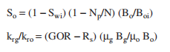

(5.21)

The above results should be compared with the averaged laboratory relative permeability data. This may indicate a needed adjustment in the early data and possibly an adjustment in the overall data.

All the techniques that are used to predict the future performance of a reservoir are based on combining the appropriate MBE with the instantaneous GOR using the proper saturation equation. The calculations are repeated at a series of assumed reservoir pressure drops. These calculations are usually based on one stock-tank barrel of oil in place at the bubble-point pressure, i.e., N = 1. This avoids carrying large numbers in the calculation procedure and permits calculations to be made on the basis of the fractional recovery of initial oil in place. There are several widely used techniques that were specifically developed to predict the performance of solution-gas-drive reservoirs, including:

* Tracy’s method
* Muskat’s method
* Tarner’s method

### 5.5.1 Mustak’S Method:

Muskat (1945) expressed the material balance equation for a depletion-drive reservoir in the following differential form:

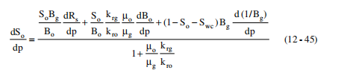

(5.21)

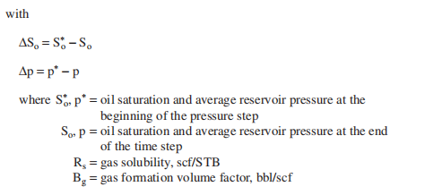

Craft, Hawkins, and Terry (1991) suggested the calculations can be greatly facilitated by computing and preparing in advance in graphical form the following pressure dependent groups :

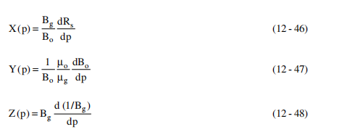

(5.24)

(5.23)

(5.22)

Introducing the above pressure dependent terms into Equation 5.21, gives

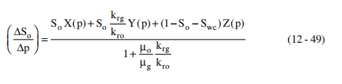

(5.25)

Craft, Hawkins, and Terry (1991) proposed the following procedure for solving Muskat’s equation for a given pressure drop Δp, i.e., (p* - p):

*Step 1.* Prepare a plot of krg/kro versus gas saturation.

Table 5.9 Ratio of Relative Gas to Relative permeability data

|  |  |
| --- | --- |
| Sg | Krg_by_Kro |
| 0.1 | 0.006247397 |
| 0.2 | 0.086419753 |
| 0.3 | 0.5616 |
| 0.4 | 3 |
| 0.5 | 16.97530864 |
| 0.6 | 135 |

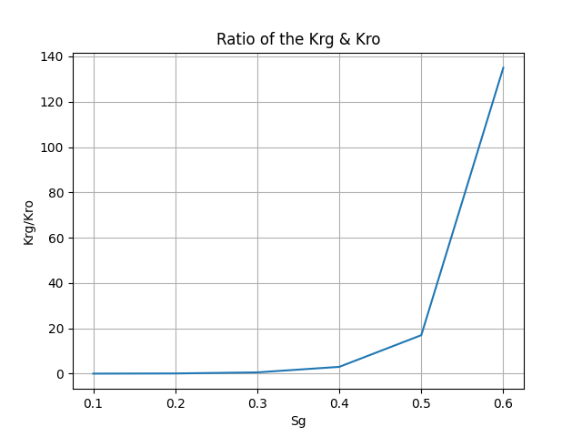

Figure 5.11 Graph between Ration of Gas relative permeability to oil relative permeability vs Gas Saturation

*Step 2.* Plot Rs, Bo and (1/Bg) versus pressure and determine the slope of each plot at selected pressures, i.e., dBo/dp, dRs/dp, and d(1/Bg)/dp



Figure 5.12 Gas Solubility vs Pressure



Figure 5.13 oil formation volume factor vs Pressure

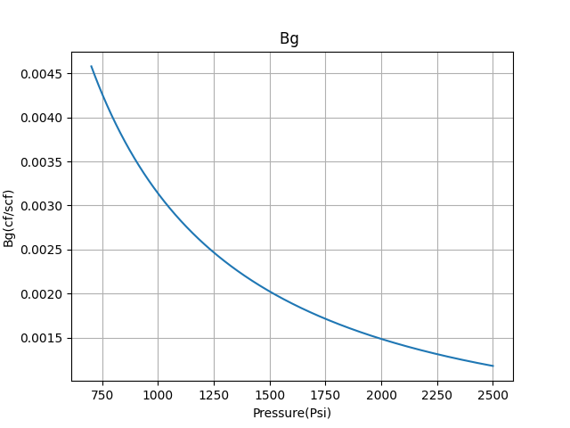

Figure 5.14 Gas formation volume factor(Bg) vs Pressure

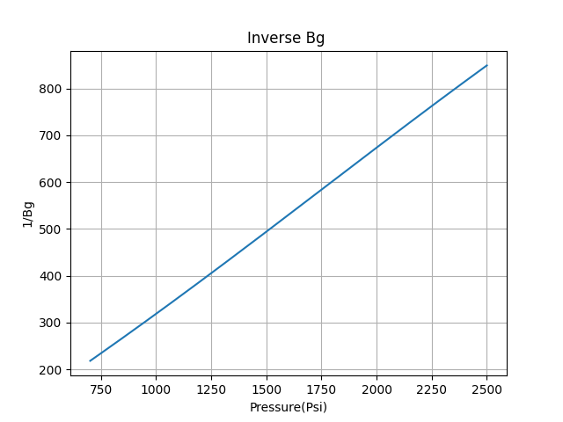

Figure 5.15 Gas expansion factor(Bg) vs Pressure

*Step 3.* Calculate the pressure dependent terms X(p), Y(p), and Z(p) that correspond to the selected pressures in Step 2.

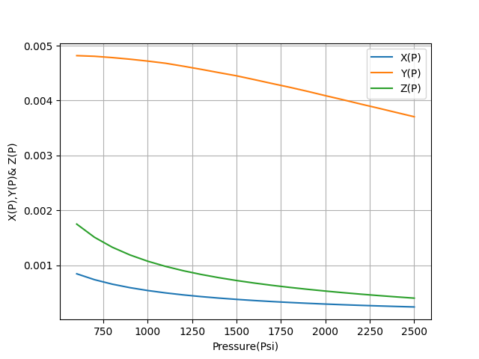

Figure 5.16 the pressure-dependent terms X(p), Y(p), and Z(p) vs pressures

*Step 4.* Plot the pressure dependent terms as a function of pressure.

*Step 5.* Graphically determine the values of X(p), Y(p), and Z(p) that correspond to the pressure P

*Step 6.* Solve Equation 5.25 for (∆So/∆p) by using the oil saturation So* at the beginning of the pressure drop interval p*.

*Step 7.* Determine the oil saturation So at the average reservoir pressure

p, from:

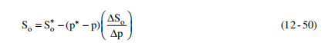

(5.26)

*Step 8.* Using the So from Step 7 and the pressure p, recalculate (∆So/∆p) from Equation 5.25.

*Step 9.* Calculate the average value for (∆So/∆p) from the two values obtained in Steps 6 and 8, or:

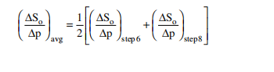

(5.27)

*Step 10.* Using (∆So/∆p)avg, solve for the oil saturation So from:

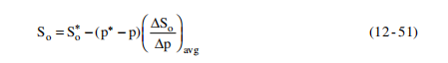

(5.28)

*Step 11.* Calculate gas saturation Sg by:



(5.29)

*Step 12.* Using the saturation equation, solve for the cumulative oil production.

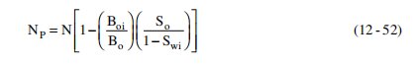

(5.30)

*Step 13.* Repeat Steps 5 through 12 for all pressure drops of interest.

Input Data for the Reservoir

API = 44.2

T = 678 R

SG of Gas = 0.781

SG of Oil =0.604

Swi = 0.2

Soi = 0.8

Sgi = 0

Pi = 2500 Psi

IOIP = 53049478 (STB)

Area = 24723278 ft^2

Rw = 0.29 ft

S = 0

KH = 647

Work Flow-Diagram:

Depletion_code.py

Generated Reservoir Performance Data

Input Data

# CHAPTER 6: TECHNO ECONOMICS

## 6.1 Basic Characteristics:

**Capital Cost**

* Capital costs are fixed, one-time expenses incurred on the purchase of land, buildings, construction, and equipment used in the production of goods or in the rendering of services. In other words, it is the total cost needed to bring a project to a commercially operable status.
* To make project techno economically feasible, we should try to keep capital cost of project minimum which includes drilling cost and surface facility cost in that.

**Operating Cost**

* Operating costs refer to the costs incurred to maintain the day-to-day operations of your business.
* In oil and gas industry, for drilling project it includes daily mud programme, contractor payment etc.
* Ultimate aim is to keep operating cost minimum to make project feasible or cost effective.

**Revenue**

* Revenue is the value of all sales of goods and services recognized by a company in a period. Revenue (also referred to as Sales or Income) forms the beginning of a company’s income statement and is often considered the “Top Line” of a business.
* Expenses are deducted from a company’s revenue to arrive at its Profit or Net Income.
* So, we can say that if revenue of company is high at the end of the time period let it be for one year, then it after deduction of cost recovery or expenses, company will be in huge profit which make project techno economical feasible.

**Taxes**

* Money paid to the government that is based on your income or the cost of goods or services you have bought.
* Taxes levied on available revenue for sharing should be minimum for project feasibility.

**Royalty**

* Royalties have historically been the most common method used by governments to gain revenue from the exploitation of the nation’s mineral endowment.
* Royalties are attractive to governments because they ensure an upfront revenue stream as soon as production starts. So low royalty rate from government side may help project owner to earn more profit which makes project techno economical.

**Discount rate**

* It only makes sense for a company to proceed with a new project if its expected revenues are larger than its expected costs—in other words, it needs to be profitable.
* The discount rate makes it possible to estimate how much the project's future cash flows would be worth in the present.

**NPV(Net Present Value)**

* Net present value (NPV) is **the difference between the present value of cash inflows and the present value of cash outflows over a period of time**. NPV is used in capital budgeting and investment planning to analyze the profitability of a projected investment or project.
* Positive NPV will make project more profitable and techno economically viable.

**IRR(Internal Rate of Return)**

* The internal rate of return (IRR) is **a metric used in financial analysis to estimate the profitability of potential investments**. IRR is a discount rate that makes the net present value (NPV) of all cash flows equal to zero in a discounted cash flow analysis.

**Abandonment costs**

* Abandonment costs or Abandonment expenditure (ABEX) are **costs associated with the abandonment of a business venture**.
* Abandonment costs traditionally applied to the process of abandoning an under producing or non-producing oil or gas well. Which includes cost of recovering land, cementing cost to close the well permanently etc. Abandonment costs should be low for project feasibility.

**Tangible Cost**

* Tangible costs related to drilling for oil and natural gas have to be depreciated over seven years. These costs pertain to the direct cost of the drilling equipment such as drilling rigs, tractors, trailers, tandem trucks, dozers, and excavators to name a few.

**Intangible Cost**

* An intangible cost is an unquantifiable cost emanating from an identifiable source that can impact, usually negatively, overall company performance. Many intangible costs arise from causes that are social, legal, or political, and ignoring them can have adverse implications.

# CHAPTER 7: RESULT AND DISCUSSION

Here we have run the Monte Carlo simulation model for reserve distribution. Here our input data are Porosity, Area, thickness, oil saturation. These all the data are stochastic variable. We have input this data into the Reserve_ Distribution.py file. Here We have also generated 100 stochastic variables, like porosity, area, thic First we run this code for the 100 times and generate 100 IOIP value.

## 7.1 Generated Random Stochastic Variables:

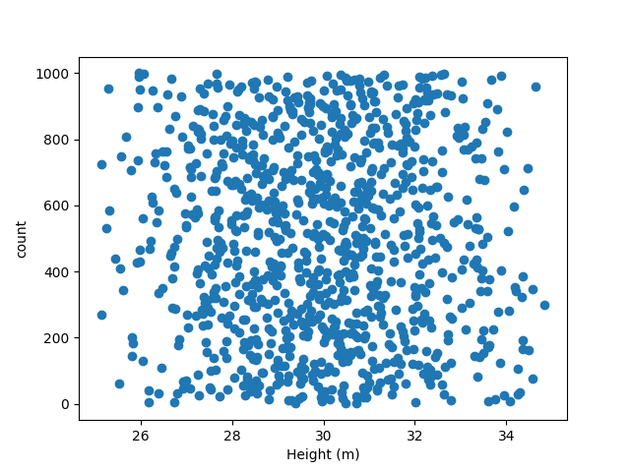

Figure 7.1 Generated 100 Random Variables

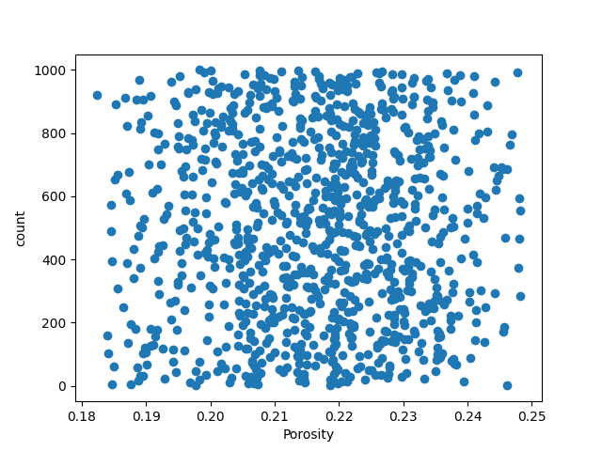

Figure7.2 Generated Random Stochastic Porosity Variables



Figure7.3 Generated Random Stochastic height Variables

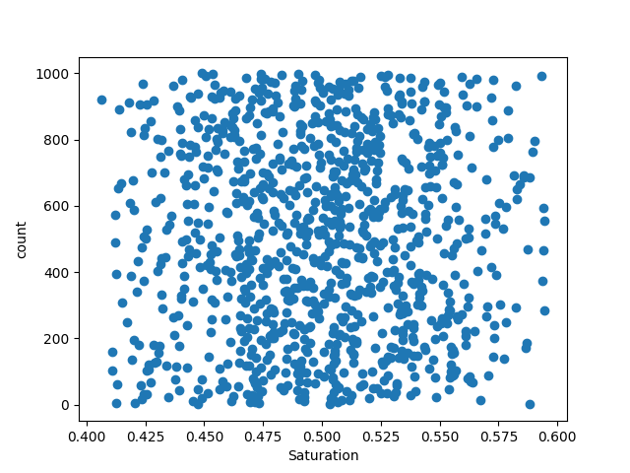

Figure 7.4 Generated Random Stochastic Saturation Variables

We have also plot the histogram and cumulative frequency data.

Here our Mean value is around 700,000 STB. So in 100 trail we have got the number of possible case along with their frequency. Base on this data we can easily determine the probability for each case.

Observation:

**100 sample…**

Table7.10 Probability of 100 Sample of IOIP

|  |  |  |
| --- | --- | --- |
| Range(m^3) | Frequency | Probability |
| 3917292-4891700 | 16 | 0.16 |
| 4891701-5866109 | 16 | 0.16 |
| 5866110-6840519 | 11 | 0.11 |
| 6840520-7814928 | 11 | 0.11 |
| 7814929-8789337 | 18 | 0.18 |
| 8789338-9763746 | 10 | 0.10 |
| 9763747-10738155 | 8 | 0.08 |
| 10738156-11712564 | 6 | 0.06 |
| 11712565-12686973 | 1 | 0.01 |
| 12686974-13661382 | 3 | 0.03 |
|  | Total 100 | Sum= 1.00 |

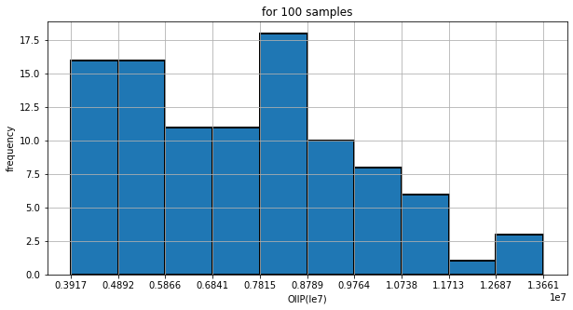

Figure 7.5 Bar chart between Frequency vs OOIP for 100 Samples

Figure **Error! Use the Home tab to apply 0 to the text that you want to appear here.**‑27.5 Bar chart between Frequency vs OOIP for 100 Samples

Observation:

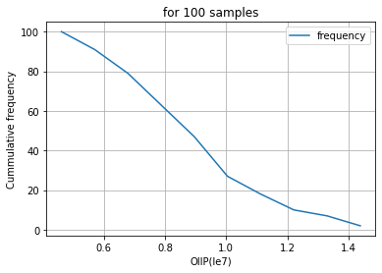

Figure 7.6 Cumulative Frequency vs OOIP for 100 Samples

Here we have generated cumulative graph for 100 trial. The X axis represents the Number of possible case and Y axis represent the frequency. Base on this graph we can interpret what is the probability for which reserve. From the data we can tell about what is P90, P50 and P10.

From the data we can analyze that our distribution of the data is vast. We are not sure about whatever data or probability of each case we have generated is right or wrong.

**Simulation For 1000 Samples**

Table 7.11 Probability of 1000 Sample of IOIP

|  |  |  |
| --- | --- | --- |
| Range(m^3) | Frequency | Probability |
| 3,721,687-4,851,523 | 74 | 0.074 |
| 4,851,524-5,981,360 | 126 | 0.126 |
| 5,981,361-7,111,197 | 192 | 0.192 |
| 7,111,198-8,241,034 | 171 | 0.171 |
| 8,241,035-9,370,871 | 164 | 0.164 |
| 9,370,872-10,500,708 | 107 | 0.107 |
| 10,500,709-11,630,546 | 75 | 0.075 |
| 11,630,547-12,760,383 | 50 | 0.05 |
| 12,760,384-13,890,220 | 33 | 0.033 |
| 13,890,221-15,020,058 | 8 | 0.008 |
|  | Total = 1000 | Sum = 1 |

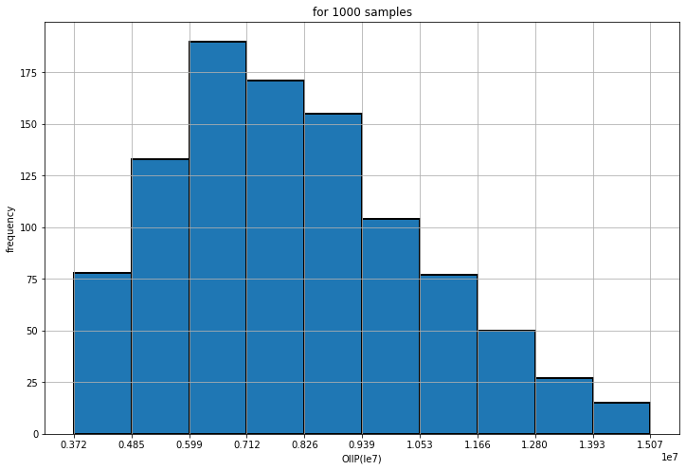

Figure 7.7 Bar chart between Frequency vs OOIP for 1000 Samples

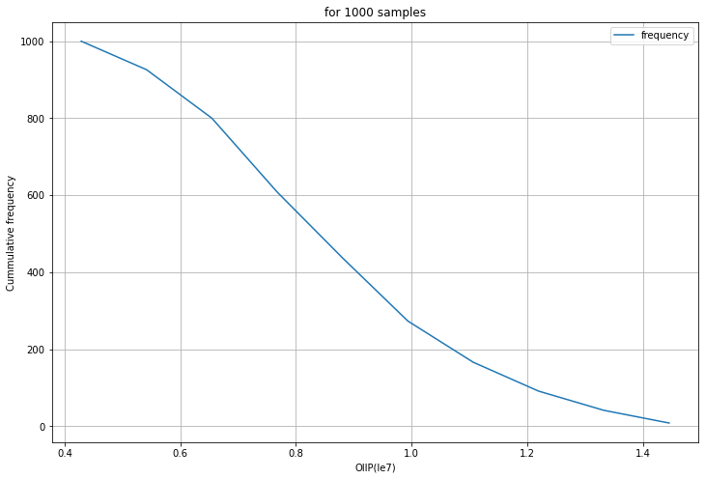

Figure 7.8 Cumulative Frequency vs OOIP for 1000 Samples

**Monte carlo simulation for 1 million samples:**

Here we have increased the number of the trial to get the accurate distribution. Here we have run the simulation for 1 Million times, We have also plot the histogram base on this data, From each case of data we analyze that as we increase the number of trials our data is converge to mean value.

**Observation:**

1 Million sample…

Table 7.12 Probability of 1 Million Sample of IOIP

|  |  |  |
| --- | --- | --- |
| Range(m^3) | Frequency | Probability |
| 3537003-4726634 | 66683 | 0.06668 |
| 4726634 -5916265 | 154787 | 0.154787 |
| 5916265 -7105896 | 194903 | 0.194903 |
| 7105896-8295528 | 188746 | 0.188746 |
| 8295528-9485159 | 142905 | 0.142905 |
| 9485159-10674790 | 102966 | 0.102966 |
| 10674790-11864421 | 70920 | 0.070920 |
| 11864421-13054052 | 45423 | 0.045423 |
| 13054052-14243683 | 24847 | 0.024847 |
| 14243683-15433314 | 7820 | 0.07820 |
|  | Total= 1,000,000 | Sum= 1.0000 |

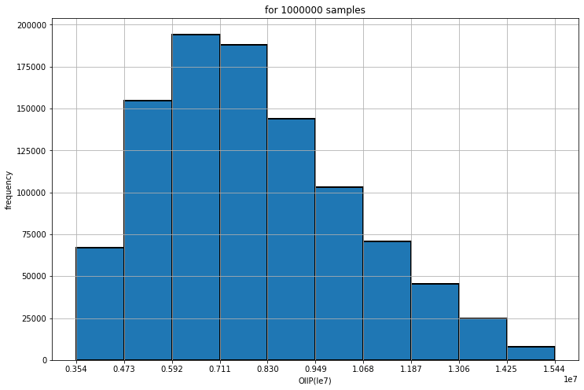

Figure 7.9 Bar chart between Frequency vs OOIP for 1 million Samples

And last two case is give moreover same distribution. The Law of large number tells that when we increase the number of trial our data is converge to mean value. Same thing here we have found from the data. From this we can say that data distribution which we have got from the 1 million sample is more accurate than distribution of the 100 samples.

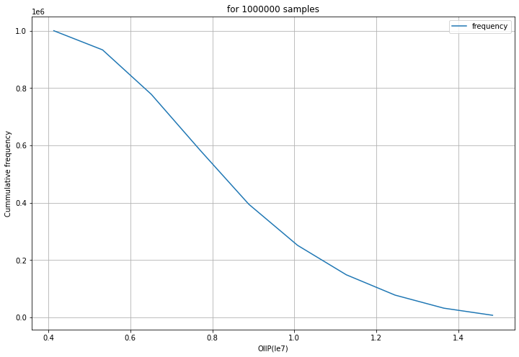

Figure 7.10 Cumulative Frequency vs OOIP for 1 million Samples

Here we have also generated cumulative frequency graph for the 1 Million sample.

From this graph we can find the P90, P50, and P10.

Here P90 = 4 Ma

P50 = 8 Ma

P10 = 10 Ma

There is 90% chance that our reserve is more than 4 Ma barrel crude oil.

There is 50% chance that our reserve is more than 8 Ma barrel Oil.

There is 10% chance that our reserve is more than 10 Ma barrel Oil.

So now it's become easy to quantify what is minimum amount of hydrocarbon will get after investing the money. So, for the investor, it's become easy for them to take the decision, whether should we do investment or not.

In this way Monte Carlo help us to quantify the risk, so we can take the calculated risk.

Generated Reservoir Performance Data (Pressure Vs Np)

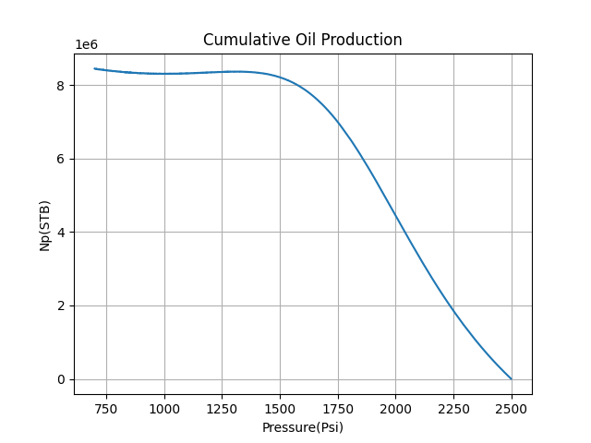

Figure 7.11 Cumulative oil production (Np) vs pressure

Table 7.13 Cumulative Production w.r.t Pressure

|  |  |
| --- | --- |
| Pressure(Psi) | Np(STB) |
| 2226 | 2076011.294 |
| 2225 | 2085340.075 |
| 2224 | 2094837.791 |
| 2223 | 2104123.408 |
| 2222 | 2113570.449 |
| 2221 | 2122919.846 |
| 2220 | 2132060.659 |
| 2219 | 2141705.267 |
| 2218 | 2150723.803 |
| 2217 | 2160348.777 |
| 2216 | 2169726.968 |
| 2215 | 2179269.769 |
| 2214 | 2188566.413 |
| 2213 | 2198247.784 |
| 2212 | 2207744.429 |
| 2211 | 2217118.194 |
| 2210 | 2226624.25 |
| 2209 | 2236132.155 |
| 2208 | 2245468.861 |
| 2207 | 2255113.257 |
| 2206 | 2264667.126 |
| 2205 | 2274179.956 |
| 2204 | 2283892.597 |
| 2203 | 2293512.148 |
| 2202 | 2303041.061 |
| 2201 | 2312462.553 |
| 2200 | 2322194.728 |
| 2199 | 2331867.946 |
| 2198 | 2341525.277 |
| 2197 | 2351224.4 |
| 2196 | 2360768.974 |
| 2195 | 2370714.308 |
| 2194 | 2380213.849 |

|  |  |
| --- | --- |
| Pressure(Psi) | Np(STB) |
| 2499 | 5978.982276 |
| 2498 | 11968.9713 |
| 2497 | 17969.21985 |
| 2496 | 23977.97073 |
| 2495 | 29996.24786 |
| 2494 | 36033.17907 |
| 2493 | 42072.08719 |
| 2492 | 48124.64485 |
| 2491 | 54183.27732 |
| 2490 | 60269.16152 |
| 2489 | 66340.357 |
| 2488 | 72450.08488 |
| 2487 | 78540.01853 |
| 2486 | 84659.47413 |
| 2485 | 90782.5364 |
| 2484 | 96927.99924 |
| 2483 | 103076.2522 |
| 2482 | 109240.0597 |
| 2481 | 115410.4592 |
| 2480 | 121591.5157 |
| 2479 | 127783.3236 |
| 2478 | 133974.4859 |
| 2477 | 140187.6635 |
| 2476 | 146398.9913 |
| 2475 | 152645.8155 |
| 2474 | 158878.2716 |
| 2473 | 165161.4893 |
| 2472 | 171400.3542 |
| 2471 | 177722.2138 |
| 2470 | 183967.0101 |
| 2469 | 190297.6973 |
| 2468 | 196592.9208 |
| 2467 | 202914.5031 |
| 2466 | 209229.9183 |
| 2465 | 215600.3997 |
| 2464 | 221927.4548 |
| 2463 | 228321.4306 |

Here we have made depletion_code.py file to generate the reservoir performance data. In the code we have used the Mustak's method to solve the material balance equation. After solving the equation we have got the Cumulative production data with respect to Depletion of pressure.

From the graph we analyze that, as the pressure decreases our cumulative production increases. At the initial time, oil is accumulated in reservoir at high pressure. Now, when we create the drawdown so fluid transport from the reservoir to the well bore.

Due to continuous production reservoir pressure decline with respect to time.

Generated Reservoir Pressure Data

Table 7.14 Reservoir Pressure, FBHP, Flow rate data w.r.t Time

|  |  |  |  |  |
| --- | --- | --- | --- | --- |
| Days | Q(STB/days) | Np(STB) | Pr(Psi) | FBHP |
| 365 | 1847.674178 | 674401.0748 | 2392 | 932.4500427 |
| 730 | 1847.674178 | 1348802.15 | 2300 | 815.2033168 |
| 1095 | 1847.674178 | 2023203.224 | 2220 | 714.4910558 |
| 1460 | 1739.548561 | 2658138.449 | 2151 | 719.5241604 |
| 1825 | 1654.293373 | 3261955.53 | 2091 | 717.2464946 |
| 2190 | 1573.216537 | 3836179.566 | 2036 | 721.5372382 |
| 2555 | 1511.225528 | 4387776.884 | 1984 | 714.9592224 |
| 2920 | 1437.160441 | 4912340.445 | 1934 | 722.4830627 |
| 3285 | 1380.530585 | 5416234.108 | 1885 | 717.1535311 |
| 3650 | 1326.132172 | 5900272.351 | 1835 | 711.1555373 |
| 4015 | 1261.1385 | 6360587.903 | 1783 | 713.682219 |
| 4380 | 1199.330165 | 6798343.414 | 1726 | 711.4763625 |
| 4745 | 1129.145543 | 7210481.537 | 1660 | 711.6127041 |
| 5110 | 1041.913059 | 7590779.803 | 1573 | 717.7271773 |
| 5475 | 942.2874943 | 7934714.739 | 795 | 712.9050519 |

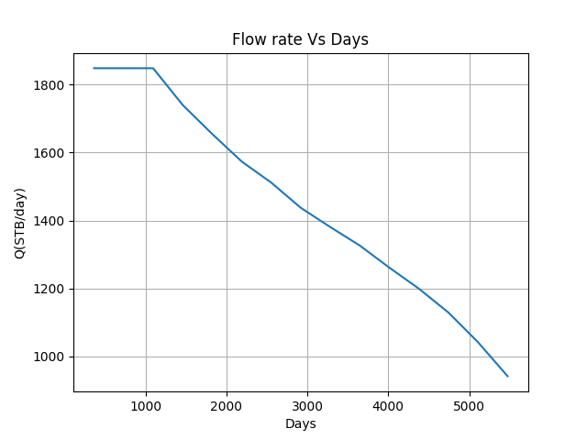

Figure 7.12 Flow rate (Q) vs Days

Here we have combined the Darcy equation with MBE to get the production profile w.r.t to time.

In production profile graph x axis represent time and Y axis represent the flow rate.

In the production profile at the initial time, our flow rate remains constant. After few years our flow rate start to decline and it's continuous decrease with respect to time. This thing happens due to reduction of the reservoir pressure.

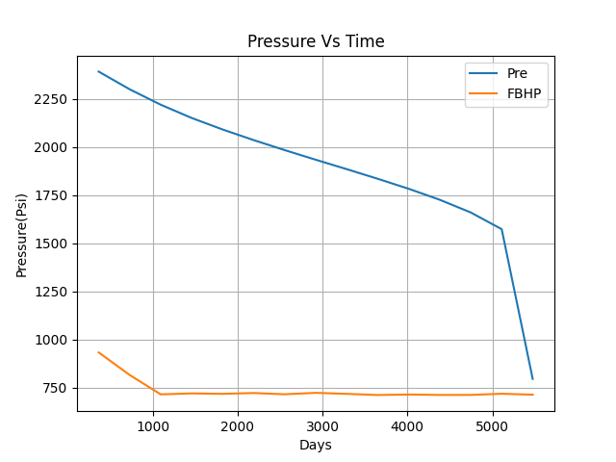

Figure 7.13 Pressure( pre, FBHP) vs Time

From the model we have also got the pressure trend of the reservoir. Here we have got pressure profile from the python code.

From the graph we analyze that there is continuous reduction of profile . Flowing bottom hole pressure also follow the same trend. Here we are producing the very high flow rate that's why there is more drawdown.

### 7.1.1 Applying Monte Carlo in Depletion Drive Reservoir

Input Data (Stochastic Variable)

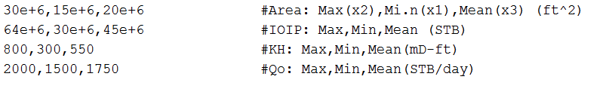

Depletion_code.py

Generated Reservoir Performance Data

Now we have applied the Monte Carlo in Depletion drive reservoir to get the multiple production profile. Here we have used Area, IOIP, KH (Permeability and thickness) and

flow rate as stochastic variable. We input this variable into Depletion_code.py file to get the multiple production profile. We run this program 25 time to generate 25 production profile. Among this profile Q23 is best case scenario, where we maintain the plateau period for more time as compare to other profile. So in Q23 condition there is high cumulative production compare to other profile.

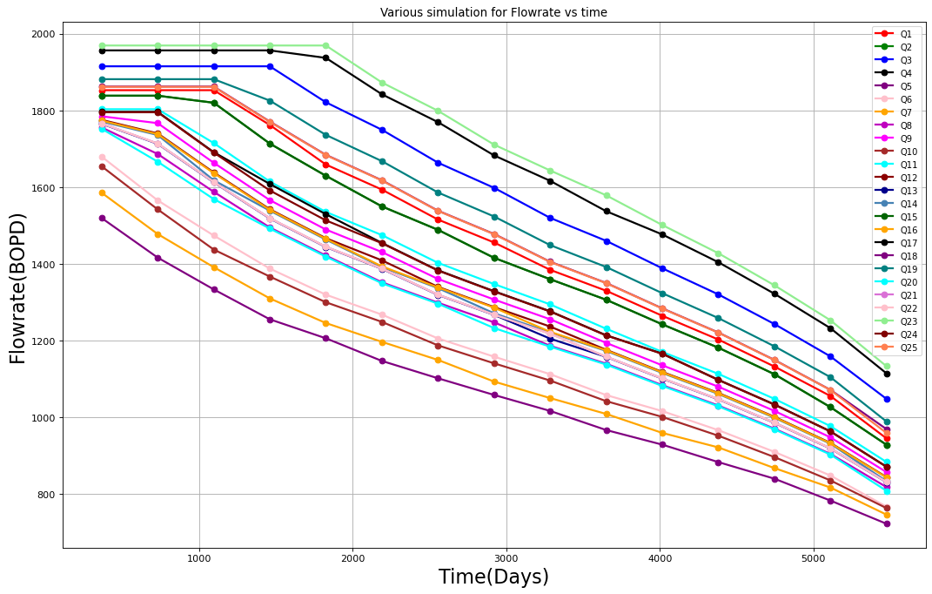

Figure 7.14 Various Simulation flow rate (Q BOPD) vs time (Days)

## 

## 7.2 Technoeconomic Analysis of Depletion Drive Reservoir:

From the Monte-carol Simulation Model, We have got the Production profile of the Reservoir. Here we have run the Code around 25 times, by using the Stochastic Variable (Area, IOIP, KH, Flow rate). After running the simulation 25 times we have got the 25 Production Profiles.

Here we have compared the Worst and the Best Production Profile Scenario out of 25 Production Profiles.

7.2.1 Worst Case Scenario

Among this profile Q25 is worst case scenario. Here we directly get the depletion period, where our flow rate is continuous decreases.

Yearly production data is given, Overall cumulative production is 5.91 MMSTB, Here our recovery factor is 11.81%

**Cash flow Data of Worst Case**

**NPV Data of Worst Case**

**Yearly Production data**

Table 7.15 Yearly Production data (Worst Case)

|  |  |
| --- | --- |
| Days | Yearly production(MMSTB) |
| 365 | 0.554449824 |
| 730 | 0.516783468 |
| 1095 | 0.486541377 |
| 1460 | 0.458069048 |
| 1825 | 0.4400193 |
| 2190 | 0.418453976 |
| 2555 | 0.40196522 |
| 2920 | 0.386126186 |
| 3285 | 0.370911274 |
| 3650 | 0.352732931 |
| 4015 | 0.338833846 |
| 4380 | 0.322227616 |
| 4745 | 0.306435257 |
| 5110 | 0.285617684 |
| 5475 | 0.263552203 |

**Yearly production data**

Table 7.17 NPV data (Worst Case)

|  |  |
| --- | --- |
| Year | ($ in millions) |
| Year 1 | -167 |
| Year 2 | -112.2641509 |
| Year 3 | 159.1664502 |
| Year 4 | 150.8262365 |
| Year 5 | 133.9426276 |
| Year 6 | 118.9614532 |
| Year 7 | 107.8424897 |
| Year 8 | 109.6577356 |
| Year 9 | 99.38849393 |
| Year 10 | 90.01562738 |
| Year 11 | 81.6264235 |
| Year 12 | 73.2163916 |
| Year 13 | 66.35494688 |
| Year 14 | 59.4960385 |
| Year 15 | 53.39192262 |
| Year 16 | 46.94771796 |
| Year17 | 40.89206723 |

Table 7.16 Cash flow data (Worst Case)

|  |  |
| --- | --- |
| Year | ($ in millions) |
| Year 1 | -167 |
| Year 2 | -119 |
| Year 3 | 178.8394234 |
| Year 4 | 179.6364609 |
| Year 5 | 169.0994813 |
| Year 6 | 159.1972594 |
| Year 7 | 152.9766328 |
| Year 8 | 164.8846894 |
| Year 9 | 158.4101597 |
| Year 10 | 152.0795084 |
| Year 11 | 146.1804925 |
| Year 12 | 138.9865706 |
| Year 13 | 133.51919 |
| Year 14 | 126.9007819 |
| Year 15 | 120.7140091 |
| Year 16 | 112.5129381 |
| Year17 | 103.8802319 |

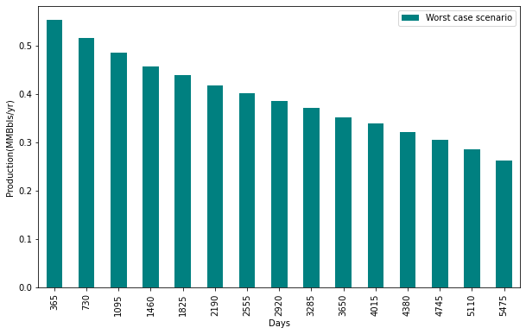

Figure 7.15 Production profile of worst-case scenario

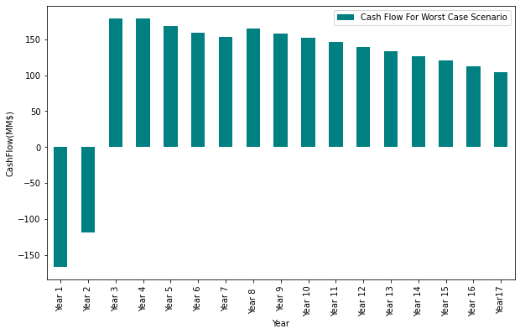

Figure 7.16 Cash flow for worst case scenario

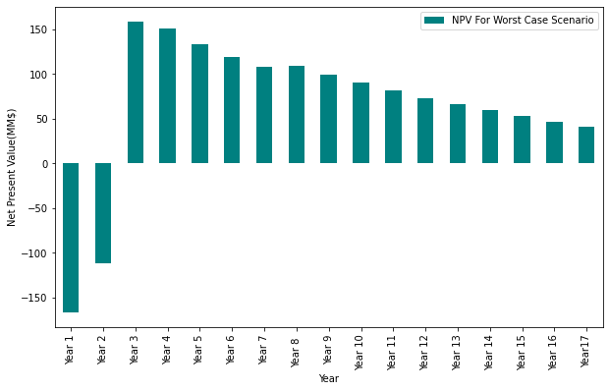

Figure 7.17 NPV for worst case scenario

### 7.2.2 Best Case Scenario

**Cash flow Data of Best**

**Case**

**Yearly Production data**

**NPV Data of Best Case**

Table 7.18 Yearly Production data (Best Case)

|  |  |
| --- | --- |
| Days | Yearly Production  (MMSTB) |
| 365 | 0.718646976 |
| 730 | 0.718646976 |
| 1095 | 0.718646976 |
| 1460 | 0.718646976 |
| 1825 | 0.718646976 |
| 2190 | 0.683426123 |
| 2555 | 0.656496407 |
| 2920 | 0.624321551 |
| 3285 | 0.599720791 |
| 3650 | 0.576089399 |
| 4015 | 0.547855286 |
| 4380 | 0.521004926 |
| 4745 | 0.490515796 |
| 5110 | 0.457192776 |
| 5475 | 0.413476951 |

Table 17.20 NPV data (Best Case)

|  |  |
| --- | --- |
| Year | ($ in millions) |
| Year 1 | -167 |
| Year 2 | -112.264150 |
| Year 3 | 209.8973612 |
| Year 4 | 209.7710484 |
| Year 5 | 197.8972155 |
| Year 6 | 186.6954863 |
| Year 7 | 176.1278173 |
| Year 8 | 179.1267723 |
| Year 9 | 162.3074588 |
| Year 10 | 145.6260386 |
| Year 11 | 132.0002104 |
| Year 12 | 119.6019316 |
| Year 13 | 107.2547633 |
| Year 14 | 96.25946364 |
| Year 15 | 85.46525874 |
| Year 16 | 75.16437709 |
| Year17 | 64.11332424 |

Table 7.19 Cash flow data (Best Case)

|  |  |
| --- | --- |
| Year | ($ in millions) |
| Year 1 | -167 |
| Year 2 | -119 |
| Year 3 | 235.840675 |
| Year 4 | 249.840675 |
| Year 5 | 249.840675 |
| Year 6 | 249.840675 |
| Year 7 | 249.840675 |
| Year 8 | 269.340435 |
| Year 9 | 258.6934306 |
| Year 10 | 246.0321281 |
| Year 11 | 236.3922728 |
| Year 12 | 227.0401744 |
| Year 13 | 215.8176563 |
| Year 14 | 205.3145303 |
| Year 15 | 193.2287416 |
| Year 16 | 180.1358038 |
| Year17 | 162.8703913 |

Here our total cumulative production is 9.16 MMSTB

Here our Recovery factor is 18.32%.

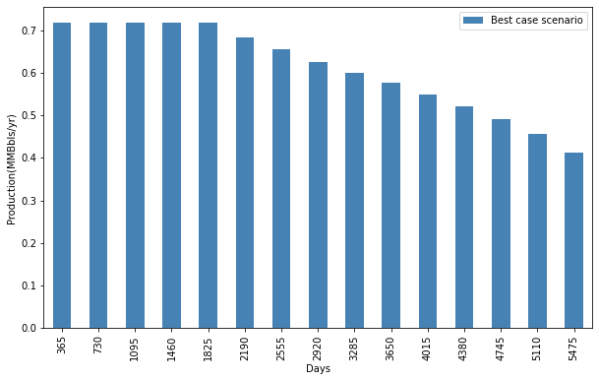

Figure 7.18 Production profile of Best case scenario

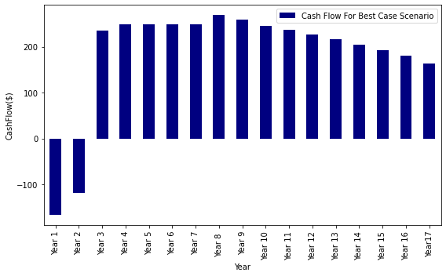

Figure 7.19 Cash flow for Best case scenario

Here we have also generated net cash flow data and graph for each case. Here we have also calculated NPV data for each case.

So from the graph we see that at the initial time our NPV is negative. After two year when we start the production we have got the positive value of NPV.

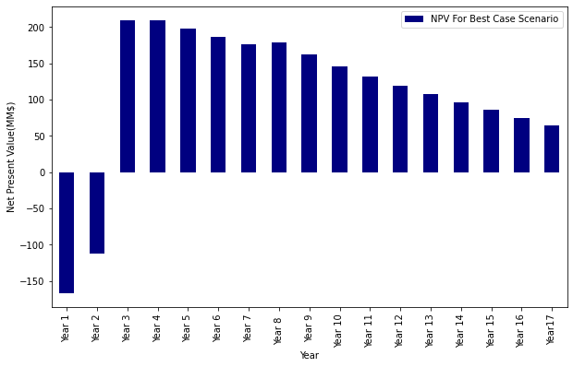

Figure 7.20 NPV for Best case scenario

**Overall Economic Analysis for the Worst case**

Table 7.21 Economic analysis of Worst Case

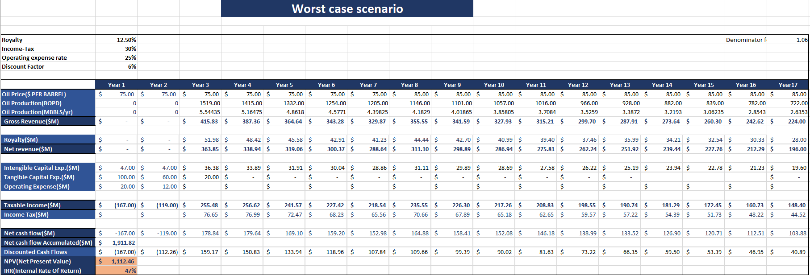

**Overall Economic Analysis of Best Case**

Table 7.21 Economic analysis of Best Case

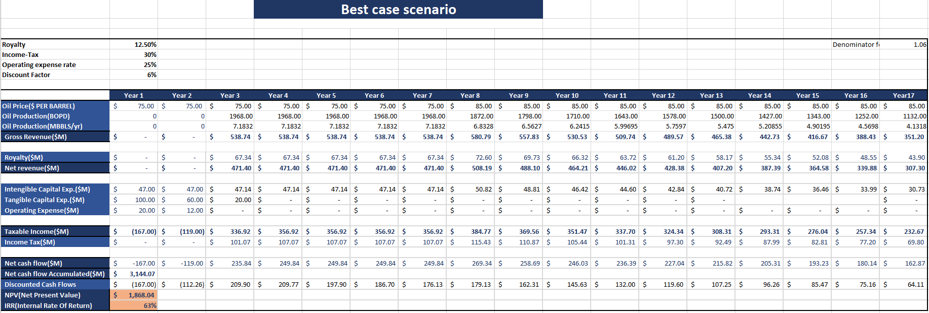

We have also done overall economic analysis for each case. Here we have calculated NPV value for each year. We are able to minimum flow rate up to the 17 years. So upto the 17 year our project is able to generate the money.

For the worst case our NPV is 1.112 $ Billion and IRR is 47%.

For the Best case our NPV is 1.868 $ Billion and IRR is 63%.

So here we have taken the best and worst case scenario. So our NPV value and IRR values lies between this range 1.112 to 1.868 $ Billion and 47 to 63 % respectively.

# CHAPTER 8: CONCLUSION

In oil and Gas Industry we have to deal with uncertain data. Even this oil and gas industry requires huge investment. So, there is high risk for the investor side to take the decision regarding the investment. In first part of our project we have generated number of Possible IOIP case along with the Probability. While increasing the number of trial our data converge to the mean value. For the 1 Million data sample, our data distribution is more accurate than 100 samples.

In second part of our project, by running the Depletion_code.py (python program) we have generated 25 production profiles. From the production profile we have taken worst case scenarios and Best case scenarios. From the both scenarios we got the range. For the Cumulative production worst case scenarios is 5.91 MMSTB and best case scenarios is 9.16 MMSTB. So, we get the range of cumulative production from 5.91 to 9.16 MMSTB. For the Recovery factor worst case scenarios is 11.81% and best case scenarios is 18.32%. So, we get the range of cumulative production from 11.81% to 18.32%. For the NPV worst case scenarios is $1.112 billion and best case scenarios is $1.868 billion So, we get the range of cumulative production from $1.112 billion to $1.868 billion. . For the IRR worst case scenarios is 47% and best case scenarios is 63%. So, we get the range of IRR is from 47% to 63%. Now we have all the range of the economic data. So if we see the NPV and IRR for both cases, then it’s gives good value for each case. So here Our Project has capacity to generate good amount of the profit after calculating the uncertain parameter. But here our recovery factor is very low. A very large amount of the crude oil is still remaining inside the reservoir. So we have to find some other alternative techniques to increase the Recovery factor.

# REFERENCES

* 1. Cole, F., *Reservoir Engineering Manual.* Houston: Gulf Publishing Compa ny, 1969.
  2. Baker, O. and Swerdloff, W., “Calculations of Surface Tension-3: Calcula tions of Surface Tension Parachor Values,” *OGJ,* December 5, 1955, Vol. 43, p. 141.
  3. Beal, C., “The Viscosity of Air, Water, Natural Gas, Crude Oils and its Associated Gases at Oil Field Temperatures and Pressures,” *Trans. AIME,* 1946, Vol. 165, pp. 94–112.
  4. Beggs, H. D. and Robinson, J. R., “Estimating the Viscosity of Crude Oil Systems,” *JPT,* September 1975, pp. 1140–1141.
  5. Brill, J. and Beggs, H., *Two-Phase Flow in Pipes.* Tulsa, OK: The University of Tulsa, 1978.
  6. Carr, N., Kobayashi, R., and Burrows, D., “Viscosity of Hydrocarbon Gases Under Pressure,” *Trans. AIME,* 1954, Vol. 201, pp. 270–275.
  7. Chew, J., and Connally, Jr., C. A., “A Viscosity Correlation for Gas-Saturated Crude Oils,” *Trans. AIME,* 1959, Vol. 216, pp. 23–25.
  8. Dean, D. E., and Stiel, L. I., “The Viscosity of Non-polar Gas Mixtures at Moderate and High Pressure,” *AIChE Jour.*, 1958, Vol. 4, pp. 430–436.
  9. Dempsey, J. R., “Computer Routine Treats Gas Viscosity as a Variable,” *Oil and Gas Journal,* Aug. 16, 1965, pp. 141–143.
  10. Dranchuk, P. M., and Abu-Kassem, J. H., “Calculation of Z-factors for Natural Gases Using Equations-of-State,” *JCPT,* July–Sept., 1975, pp. 34–36.
  11. Dranchuk, P. M., Purvis, R. A., and Robinson, D. B., “Computer Calculations of Natural Gas Compressibility Factors Using the Standing and Katz Correlation,” *Inst. Of Petroleum Technical Series,* No. IP 74-008, 1974.
  12. Fanchi, J. R., “Calculation of Parachors for Composition Simulation,” *JPT,* November 1985, pp. 2049–2050.
  13. Glaso, O., “Generalized Pressure-Volume-Temperature Correlations,” *JPT,* May 1980, pp. 785–795.
  14. Hall, K. R., and Yarborough, L., “A New Equation-of-State for Z-factor Calculations,” *Oil and Gas Journal,* June 18, 1973, pp. 82–92.
  15. Properties,” *Hydrocarbon Processing,* April 1969, pp. 106–108.
  16. Kay, W. B., “Density of Hydrocarbon Gases and Vapor,” *Industrial and Engineering Chemistry,* 1936, Vol. 28, pp. 1014–1019.
  17. Lee, A. L., Gonzalez, M. H., and Eakin, B. E., “The Viscosity of Natural Gases,” *JTP,* August 1966, pp. 997–1000.
  18. Marhoun, M. A., “PVT Correlation for Middle East Crude Oils,” *JPT,* May 1988, pp. 650–665.
  19. Mattar, L. G., Brar, S., and Aziz, K., “Compressibility of Natural Gases,” *Journal of Canadian Petroleum Technology,* October–November 1975, pp. 77–80.
  20. Meehan, D. N., “A Correlation for Water Compressibility,” *Petroleum Engineer,* November 1980, pp. 125–126.
  21. Papay, J., “A Termelestechnologiai Parameterek Valtozasa a Gazlelepk Muvelese Soran,” *OGIL MUSZ,* Tud, Kuzl., Budapest, 1968, pp. 267–273.
  22. Petrosky, G. E., and Farshad, F., “Pressure-Volume-Temperature Correlations for Gulf of Mexico Crude Oils,” SPE Paper 26644, presented at the 68th Annual Technical Conference of the SPE in Houston, Texas, 3–6 October, 1993.
  23. Standing, M. B., *Volumetric and Phase Behavior of Oil Field Hydrocarbon Systems,* pp. 125–126. Dallas: Society of Petroleum Engineers, 1977.
  24. Standing, M. B. and Katz, D. L., “Density of Natural Gases,” *Trans. AIME,* 1942, Vol. 146, pp. 140–149.
  25. Stewart, W. F., Burkhard, S. F., and Voo, D., “Prediction of Pseudo-Critical Parameters for Mixtures,” paper presented at the AIChE Meeting, Kansas City, MO, 1959.
  26. Sugden, S., “The Variation of Surface Tension, VI. The Variation of Surface Tension with Temperature and Some Related Functions,” *J. Chem. Soc.*, 1924, Vol. 125, pp. 32–39.
  27. Sutton, R. P., “Compressibility Factors for High-Molecular-Weight Reservoir Gases,” SPE Paper 14265, presented at the 60th Annual Technical Conference and Exhibition of the Society of Petroleum Engineers, Las Vegas, Sept. 22–25, 1985.
  28. Sutton, R. P., and Farshad, F. F., “Evaluation of Empirically Derived PVT Properties for Gulf of Mexico Crude Oils,” SPE Paper 13172, presented at the 59th Annual Technical Conference, Houston, Texas, 1984.
  29. Takacs, G., “Comparisons Made for Computer Z-Factor Calculation,” *Oil and Gas Journal,* Dec. 20, 1976, pp. 64–66.
  30. Ahmed, T., “Compositional Modeling of Tyler and Mission Canyon Formation Oils with CO2 and Lean Gases,” final report submitted to Montana’s New Track for Science (MONTS) (Montana National Science Foundation Grant Program), 1985–88
  31. Craft, B. C., and Hawkins, M. (revised by Terry, R. E.), *Applied Petroleum*  *Reservoir Engineering,* 2nd ed. Englewood Cliffs, NJ: Prentice Hall, 1991.
  32. Dake, L. P., *Fundamentals of Reservoir Engineering.* Amsterdam, Elsevier, 1978.
  33. Economides, M., Hill, A., and Economides, C., *Petroleum Production Systems.* Englewood Cliffs, NJ: Prentice Hall, 1994.
  34. Havlena, D., and Odeh, A. S., “The Material Balance as an Equation of a Straight Line,” *JPT,* August 1963, pp. 896–900.
  35. Havlena, D., and Odeh, A. S., “The Material Balance as an Equation of a Straight Line. Part II—Field Cases,” *JPT,* July 1964, pp. 815–822.
  36. Hawkins, M., “Material Balances in Expansion Type Reservoirs Above Bubble-Point,” SPE Transactions Reprint Series No. 3, 1955, pp. 36–40.
  37. Muskat, M., “The Production Histories of Oil Producing Gas-Drive Reservoirs,” *Journal of Applied Physics,* 1945, Vol. 16, p. 167.
  38. Tarner, J., “How Different Size Gas Caps and Pressure Maintenance Programs Affect Amount of Recoverable Oil,” *Oil Weekly,* June 12, 1944, Vol. 144.
  39. Tracy, G., Simplified Form of the MBE,” *Trans. AIME,* 1955, Vol. 204, pp.
  40. Vogel, J. V., “Inflow Performance Relationships for Three Phase Flow,” SPE Paper 25458 presented at the SPE Production Operations Symposium, Oklahoma City, March 21–23, 1993.
  41. Introduction to petroleum economics by Chris Hinkin, 26 August 2020
  42. Petroleum economics and risk analysis: A practical guide to E&P Investment Decision-Making by Mark Cook, 29 January 2021

# APPENDIX

**Appendix I: Python code for monte carlo simulation for IOIP**

**import** **math** **as** **m**

**import** **pandas** **as** **pd**

**import** **numpy** **as** **np**

**import** **matplotlib.pyplot** **as** **plt**

*"""*

*Here Data is imported from data.txt file and converted*

*this data into array form*

*"""*

Data = np.genfromtxt("Reserve_Data.txt",delimiter=',')

FVF = Data[0,0]

Porosity = []

Saturation = []

Height = []

Area = []

IOIP_L = []

**def** IOIP(A, h, So, Phi, FVF):

*"""*

*:param A: Area(m^2)*

*:param h: Thickness (m)*

*:param Sw: Saturation of oil*

*:param Phi: Porosity*

*:param FVF: Formation Volume factor*

*:return: Initial Oil in place (m^3)*

*"""*

Oil_in_place = (A*h*So*Phi)/FVF

**return** Oil_in_place

*# Sampling the Data (Random Variable)*

**for** i **in** range(100):

rd = np.random.random() *# Random Number*

*# Random Variable 1 : Porosity*

*"""*

*To generate 100 Random Variable For Porosity*

*Triangle Distribution*

*"""*

**if** rd <= ((Data[3,2] -Data[3,1])/(Data[3,0]-Data[3,1])):

X = Data[3,1] + m.sqrt(rd*(Data[3,2] -Data[3,1])*(Data[3,0]-Data[3,1]))

**elif** rd >= ((Data[3,2] -Data[3,1])/Data[3,0]-Data[3,1]):

X = Data[3,0] - m.sqrt((1-rd)*(Data[3,0]-Data[3,2] )*(Data[3,0]-Data[3,1]))

Porosity.append(X)

*# Random Variable 2 : Saturation*

*"""*

*To generate 100 Random Variable for the Saturation*

*Triangle Distribution*

*"""*

**if** rd <= ((Data[4,2] -Data[4,1])/(Data[4,0]-Data[4,1])):

X1 = Data[4,1] + m.sqrt(rd*(Data[4,2] -Data[4,1])*(Data[4,0]-Data[4,1]))

**elif** rd >= ((Data[4,2] -Data[4,1])/Data[4,0]-Data[4,1]):

X1 = Data[4,0] - m.sqrt((1-rd)*(Data[4,0]-Data[4,2] )*(Data[4,0]-Data[4,1]))

Saturation.append(X1)

*# Random Variable 3: Height (meter)*

*"""*

*To generate 100 Random Variable for the Height*

*Triangle Distribution*

*"""*

**if** rd <= ((Data[5,2] -Data[5,1])/(Data[5,0]-Data[5,1])):

X2 = Data[5,1] + m.sqrt(rd*(Data[5,2] -Data[5,1])*(Data[5,0]-Data[5,1]))

**elif** rd >= ((Data[5,2] -Data[5,1])/Data[5,0]-Data[5,1]):

X2 = Data[5,0] - m.sqrt((1-rd)*(Data[5,0]-Data[5,2] )*(Data[5,0]-Data[5,1]))

Height.append(X2)

*# Random Variable 4 : Area (m^2)*

*"""*

*To generate 100 Random Variable for the area*

*Triangle Distribution*

*"""*

**if** rd <= ((Data[2,2] -Data[2,1])/(Data[2,0]-Data[2,1])):

X3 = Data[2,1] + m.sqrt(rd*(Data[2,2] -Data[2,1])*(Data[2,0]-Data[2,1]))

**elif** rd >= ((Data[2,2] -Data[2,1])/Data[2,0]-Data[2,1]):

X3 = Data[2,0] - m.sqrt((1-rd)*(Data[2,0]-Data[2,2] )*(Data[2,0]-Data[2,1]))

Area.append(X3)

*"""*

*Find oil initial in place*

*"""*

Oil_in_place = IOIP(X3,X2,X1,X,FVF)

IOIP_L.append(Oil_in_place)

dict1 = {"porosity":Porosity,

"Saturation":Saturation,

"Height(m)":Height,

"Area(m^2)":Area,

"Oil in Place(m^3)":IOIP_L}

print("Dict1",dict1)

df = pd.DataFrame(dict1)

print(df)

*#df.to_excel("Reserve_Calculation.xlsx")*

x = IOIP_L

plt.hist(x,10,ec="red")

plt.xlabel("OIIP (m^3)")

plt.ylabel("count")

plt.show()

**Appendix II: Python code Application of monte carlo in depletion drive reservoir**

**import** **math** **as** **m**

**import** **pandas** **as** **pd**

**import** **numpy** **as** **np**

**import** **matplotlib.pyplot** **as** **plt**

**from** **scipy.optimize** **import** curve_fit

*"""*

*Here Data is imported from data.txt file and converted*

*this data into array form*

*"""*

Data1 = np.genfromtxt("Depletion_Data.txt",delimiter=',')

*"""*

*Here Data is imported from data.txt file and converted*

*this data into array form*

*"""*

Data2 = np.genfromtxt("Application_Data.txt",delimiter=',')

*"""*

*Using the Corelation to find the PVT properties*

*Making all the Co-relation as the Function of the Pressure*

*"""*

**def** Rs_GOR(P):

*"""*

*This function gives value of Solution GOR*

*:param P: Pressure (Psi)*

*:return: solution GOR (SCF/STB)*

*"""*

x = (7.916*(0.0001)*Data1[0][0]**1.541) - 4.561*(0.00001)*(Data1[0][1]-460)**1.3911

Rs = (((P/112.727)+ 12.340)*((Data1[0][2])**0.8439)*(10**x))**1.73184

**return** Rs

**def** OIL_FVF(P):

*"""*

*Standing Corelation*

*This function gives value of oil formation volume factor*

*:param Rs: Solution GOR (Scf/STB)*

*:return: Oil formation volume factor (bbl/STB)*

*"""*

Rs = Rs_GOR(P)

Bo = 0.9759 + 0.000120*(Rs*((Data1[0][2]/Data1[0][3])**0.5)+1.25*(Data1[0][1]-460))**1.2

**return** Bo

**def** Muo_Oil(P):

*"""*

*This function gives value of the oil at pressure*

*:param Rs: Gas solubiolity (SCF/STB)*

*:return: Saturated oil viscosity (cp)*

*"""*

Rs = Rs_GOR(P)

Z = 3.0324 - 0.020238*Data1[0][0]

Y = 10**Z

X = Y*(Data1[0][1]-460)**(-1.163)

Muo_d = 10**X - 1 *#Dead oil viscosity (P = 14.7 psi)*

a = 10.715 * (Rs + 100) ** (-0.515)

b = 5.44 * (Rs + 150) ** (-0.338)

Mu_ob = a * ((Muo_d) ** b) *#Viscosity at Bubble point Pressure*

**return** Mu_ob

**def** viscosity_gas(P):

*"""*

*This Function gives the value of the Viscosity of gas*

*:param P: Reservoir Pressure (Psi)*

*:return: Viscosity (cP)*

*"""*

Mw = Data1[0][2]*28.96 *# Molecular of weight of gas*

Z = Z_factor(P)

Rho_G = (1.4935*1e-3*P*Mw)/(Z*Data1[0][1]) *# Density of gas(in gm/cc)*

K = ((9.4+0.02*Mw)*(Data1[0][1]**1.5))/(209+19*Mw+Data1[0][1])

X = 3.5+(986/Data1[0][1])+0.01*Mw

Y = 2.4-0.2*X

Mug = 1e-4*K*m.exp(X*(Rho_G)**Y) *# Visocity (In cP)*

**return** Mug

**def** Z_factor(P):

*"""*

*This function Gas compresibility factor*

*:param P: Pressure (Psi)*

*:return: z (Compresiblity Factor)*

*"""*

**if** Data1[0][2] < 0.75:

*# Here gas consider as dry gas*

Tc = 168 + 325 * Data1[0][2] - 12.5 * (Data1[0][2]) ** 2 *# In degree Renkine unit*

Pc = 677 + 15 * Data1[0][2] - 37.5 * (Data1[0][2]) ** 2 *# In psia unit*

**else**:

*# Here gas consider as wet gas*

*# Here specific gravity is more than the 0.75*

Tc = 187 + 330 * Data1[0][2] - 71.5 * (Data1[0][2]) ** 2 *# In degree Renkine unit*

Pc = 706 + 51.7 * Data1[0][2] - 11.1 * (Data1[0][2]) ** 2 *# In psia unit*

Tr = Data1[0][1] / Tc *# Reduce Temperature*

Pr = P / Pc *# Reduce Pressure*

*"""*

*The Hall-Yarboprough Metho to find the Z-Factor*

*"""*

tr = Tr

pr = Pr

t = 1 / tr

X1 = -0.06125 * t * pr * (m.exp((-1.2) * (1 - t) ** 2))

X2 = 14.76 * t - 9.76 * (t ** 2) + 4.58 * (t ** 3)

X3 = 90.7 * t - 242.2 * (t ** 2) + 42.4 * (t ** 3)

X4 = 2.18 + 2.82 * t

y = 0.0125 * pr * t * (m.exp(-1.2 * (1 - t) ** 2))

*"""*

*Newton Rapson Method Use to solve the Non-linear*

*equation*

*"""*

**for** i **in** range(10000):

fny = X1 + (y + y ** 2 + y ** 3 + y ** 4) / ((1 - y) ** 3) - X2 * (y ** 2) + X3 * (y ** X4)

dfny = ((1+4*y+4*(y**2)-4*(y**3)+y**4)/((1-y)**4)) - (2*X2*y) + X3*X4*(y**(X4-1))

y_new = y - (fny / dfny)

**if** abs(y_new - y) < 1e-12:

**break**

y = y_new

y1 = y_new

z = (0.06125 * pr * t * m.exp(-1.2 * (1 - t) ** 2)) / y1

**return** z

**def** Inverse_FVF_gas(P):

*"""*

*This function guives value of Gas formation volume factor*

*:param P: Pressure (Psi)*

*:return: Gas Formation volume factor(bbl/scf)*

*"""*

Z_fac = Z_factor(P)

Bg = (0.005035*Z_fac*Data1[0][1])/P

**return** 1/Bg

**def** FVF_gas(P):

*"""*

*This function guives value of Gas formation volume factor*

*:param P: Pressure (Psi)*

*:return: Gas Formation volume factore (cf/scf)*

*"""*

Z_fac = Z_factor(P)

Bg = (0.005035*Z_fac*Data1[0][1])/P

**return** Bg

**def** Rel_K(Sg):

*"""*

*Using Corile's Corelation to Get Relative Permeability*

*:param Sg: Saturation of Gas*

*:return: Kro*

*"""*

Sg_star = Sg / (1 - Data1[1][0])

Kro = (1 - Sg_star) ** 4

Krg = (Sg_star ** 3) * (2 - Sg_star)

**return** Kro

**def** Rel_Kg(Sg):

Sg_star = Sg / (1 - Data1[1][0])

Kro = (1-Sg_star)**4

Krg = (Sg_star**3)*(2-Sg_star)

**return** Krg

**def** Ratio_Rel_K(Sg):

Sg_star = Sg/(1-Data1[1][0])

Kro = (1-Sg_star)**4

Krg = (Sg_star**3)*(2-Sg_star)

**return** Krg/Kro

**def** dRs_by_dP(P):

*"""*

*This Function gives derivative of the Gas solubility*

*:param P: Pressuer(Psi)*

*:return: derivative*

*"""*

h = 0.00000001

**return** (Rs_GOR(P+h) - Rs_GOR(P))/h

**def** dBo_by_dP(P):

*"""*

*This function gives the derivative of the oil formation volume factor*

*:param P: Pressure(Psi)*

*:return: Derivative of the Bo*

*"""*

h = 0.00000001

Rs_1 = Rs_GOR(P)

Rs_2 = Rs_GOR(P+h)

**return** (OIL_FVF(Rs_2) - OIL_FVF(Rs_1))/h

**def** dP_by_dBg(P):

*"""*

*This Function give the Derivative of the Inverse the Bg*

*:param P: Pressure(Psi)*

*:return: Gives d(1/Bg)/dP*

*"""*

h = 0.00000001

**return** (Inverse_FVF_gas(P+h)-Inverse_FVF_gas(P))/h

**def** X_of_P(P):

**return** (FVF_gas(P) / OIL_FVF(P)) * dRs_by_dP(P)

**def** Y_of_P(P):

**return** (1/OIL_FVF(P))*(Muo_Oil(P)/viscosity_gas(P))*dBo_by_dP(P)*10

**def** Z_of_P(P):

**return** FVF_gas(P) * dP_by_dBg(P)

*"""*

*Following the Stepes which are written in the Tarik-Ahemad*

*Book*

*"""*

*# Step: 3 Prepare the Graph between the X_of_P,Y_of_P and Z_of_P and P*

X = []

Pr = []

Y = []

Z = []

**for** i **in** range(2500,500,-100):

P = i

X_of_P1 = X_of_P(P)

Y_of_P1 = Y_of_P(P)

Z_of_P1 = Z_of_P(P)

Pr.append(i)

X.append(X_of_P1)

Y.append(Y_of_P1)

Z.append(Z_of_P1)

dict1 = {"Pressure":Pr,

"X_of_P":X,

"Y_of_P":Y,

"Z_of_P":Z}

df = pd.DataFrame(dict1)

print(df)

plt.plot(df["Pressure"],df["X_of_P"],label = 'X(P)')

plt.plot(df["Pressure"],df["Y_of_P"],label="Y(P)")

plt.plot(df["Pressure"],df["Z_of_P"],label = "Z(P)")

plt.legend()

plt.xlabel("Pressure(Psi)")

plt.ylabel("X(P),Y(P)& Z(P)")

plt.grid()

plt.show()

*#Step_6: solve the Mustak Equation*

P_i = Data1[1][3]

Sgi = Data1[1][2]

Sg = Sgi

Soi = Data1[1][1]

So = Soi

**def** del_So_by_del_P(P,So,Sg):

**return** ((So*X_of_P(P)) + (So*Ratio_Rel_K(Sg)*Y_of_P(P)) + (1-So-Data1[1][0])*Z_of_P(P))/(1+(Muo_Oil(P)/viscosity_gas(P))*Ratio_Rel_K(Sg))

Pre_Psi = []

Np_STB = []

Gp_SCF = []

Saturation_Oil = []

Saturation_Gas = []

Bo = []

Relative_K = []

I_GOR = []

Krg = []

So_by_Bo = []

*"""*

*Random Variable 2 : IOIP(STB)*

*Generating 100 Variable of the IOIP*

*"""*

rd = np.random.random()

**if** rd<=((Data2[1][2]-Data2[1][1])/(Data2[1][0]-Data2[1][1])):

IOIP1 = Data2[1][1] + m.sqrt(rd*(Data2[1][2]-Data2[1][1])*(Data2[1][0]-Data2[1][1]))

**elif** rd>= ((Data2[1][2]-Data2[1][1])/(Data2[1][0]-Data2[1][1])):

IOIP1 = Data2[1][0]- m.sqrt((1-rd)*(Data2[1][0]-Data2[1][2])*(Data2[1][0]-Data2[1][1]))

*# Cumulative Oil Production*

P = 2500

**for** i **in** range(2500,700,-1):

P_new = i-1

dSo_by_dP_1 = del_So_by_del_P(P, So, Sg) *#This term Constant For Every Iteration*

So_new = Soi - (P - P_new) * del_So_by_del_P(P, So, Sg)

Sg_1 = 1 - Data1[1][0] - So_new

dSo_by_dP_2 = del_So_by_del_P(P_new, So_new, Sg_1)

dSo_by_dP_avg = (dSo_by_dP_1 + dSo_by_dP_2) / 2

So_2 = Soi - (P - P_new) * dSo_by_dP_avg

Sg_f = 1 - Data1[1][0] - So_2

K = Rel_K(Sg_f)

Rel_Krg = Rel_Kg(Sg_f)

Np = IOIP1 * (1 - ((OIL_FVF(P) / OIL_FVF(P_new)) * (So_2 / (1 - Data1[1][0]))))

*#GOR_1 = Rs_GOR(P) + Ratio_Rel_K(Sg) * (Muo_Oil(P) / viscosity_gas(P))*

GOR_2 = Rs_GOR(P_new) + (Ratio_Rel_K(Sg_f) * (Muo_Oil(P_new) / viscosity_gas(P_new)))

*#Gp = ((GOR_1 + GOR_2) / 2) * Np*

Pre_Psi.append(P_new)

Np_STB.append(Np)

*#Gp_SCF.append(Gp)*

Saturation_Oil.append(So_2)

Saturation_Gas.append(Sg_f)

Bo.append(OIL_FVF(P_new))

So_by_Bo.append(So_2/OIL_FVF(P_new))

Relative_K.append(K)

Krg.append(Rel_Krg)

I_GOR.append(GOR_2)

*#So = So_2*

*#Sg = Sg_f*

dict2 = {"Pressure(Psi)":Pre_Psi,

"Np(STB)":Np_STB,

"So":Saturation_Oil,

"Sg":Saturation_Gas,

"Bo":Bo,

"Relative":Relative_K,

"Krg":Krg,

"So/Bo":So_by_Bo,

"I_GOR1(SCF/STB)":I_GOR}

df2 = pd.DataFrame(dict2)

*#df2.to_excel("Np_&_data_r1100.xlsx")*

print(df2)

*"""*

*plt.plot(Saturation_Gas,Krg)*

*plt.title("Krg Vs Sg")*

*plt.xlabel("Sg")*

*plt.ylabel("Krg")*

*plt.grid()*

*plt.show()*

*plt.plot(Pre_Psi,Krg)*

*plt.title("Krg Vs P")*

*plt.xlabel("Pressure(Psi)")*

*plt.ylabel("Krg")*

*plt.grid()*

*plt.show()*

*plt.plot(Pre_Psi,Np_STB)*

*plt.title("Cumulative Oil Production")*

*plt.xlabel("Pressure(Psi)")*

*plt.ylabel("Np(STB)")*

*plt.grid()*

*plt.show()*

*plt.plot(Pre_Psi,Saturation_Oil)*

*plt.title("Saturation")*

*plt.xlabel("Pressure(Psi)")*

*plt.ylabel("So")*

*plt.grid()*

*plt.show()*

*plt.plot(Pre_Psi,I_GOR)*

*plt.title("I_GOR")*

*plt.xlabel("Pressure(Psi)")*

*plt.ylabel("I_GOR(SCF/STB)")*

*plt.grid()*

*plt.show()*

*"""*

*"""*

*Calculation of the Reservoir Pressure*

*"""*

**def** R_H_S(Np):

**return** ((1-Data1[1][0])/OIL_FVF(Data1[1][3]))*(1-(Np/Data1[0][0]))

**def** Reservoir_P(Np):

RHS = Np

i = 0

**while** **True**:

LHS = df2["Np(STB)"][i]

**if** abs(LHS-RHS)<6000:

*#print(LHS-RHS)*

P = df2["Pressure(Psi)"][i]

*#print("P Np",P,Np)*

**break**

i = i+1

**return** P

*# Combination of Darcy and MBE*

**def** Re(A):

*"""*

*This function gives the value of Draniage radius*

*:param A: Area*

*:return: Radius (in ft)*

*"""*

**return** m.sqrt(A/m.pi)

**def** Qmax():

*"""*

*This Function Gives Maximum Flow Rate*

*:return: Qmax (STB/day)*

*"""*

**return** (0.00708*Data1[2][2]*Rel_K(Data1[1][2])*Data1[1][3])/(Muo_Oil(Data1[1][3])*OIL_FVF(Data1[1][3])*(deno))

**def** FBHP(Qo,P,A,KH):

*"""*

*Gives the Flowing bottom hole Pressure*

*:param Qo: Oil flow Rate (STB/day)*

*:param P: Pressure(Psi)*

*:return: Flowing Bottom Hole Pressure(psi)*

*"""*

deno = m.log(Re(A) / Data1[2][3], m.e) - 0.75 + Data1[3][0]

Pwf = P - ((141.2*Qo*Muo_Oil(P)*OIL_FVF(P)*deno)/KH)

**return** Pwf

FBHP_L = []

Pre_Reservoir_L = []

Q_L = []

Np_L = []

Days_L = []

P = 2500

**for** i **in** range(1):

*"""*

*Random VAriable 1: Qo (STB/day)*

*Generating 100 VAriable of the Qo*

*"""*

**if** rd <= ((Data2[3][2] - Data2[3][1]) / (Data2[3][0] - Data2[3][1])):

Qo1 = Data2[3][1] + m.sqrt(rd * (Data2[3][2] - Data2[3][1]) * (Data2[3][0] - Data2[3][1]))

**elif** rd >= ((Data2[3][2] - Data2[3][1]) / (Data2[3][0] - Data2[3][1])):

Qo1 = Data2[3][0] - m.sqrt((1 - rd) * (Data2[3][0] - Data2[3][2]) * (Data2[3][0] - Data2[3][1]))

*"""*

*Random Variable 2: Area(ft^2)*

*Generating 100 rnadom variable of the Area*

*"""*

**if** rd<=((Data2[0][2]-Data2[0][1])/(Data2[0][0]-Data2[0][1])):

A1 = Data2[0][1] + m.sqrt(rd*(Data2[0][2]-Data2[0][1])*(Data2[0][0]-Data2[0][1]))

**elif** rd>= ((Data2[0][2]-Data2[0][1])/(Data2[0][0]-Data2[0][1])):

A1 = Data2[0][0]- m.sqrt((1-rd)*(Data2[0][0]-Data2[0][2])*(Data2[0][0]-Data2[0][1]))

*"""*

*Random Variable 3: KH(mD-ft)*

*Generating 100 Variable of the KH*

*"""*

**if** rd <= ((Data2[2][2] - Data2[2][1]) / (Data2[2][0] - Data2[2][1])):

KH1 = Data2[2][1] + m.sqrt(rd * (Data2[2][2] - Data2[2][1]) * (Data2[2][0] - Data2[2][1]))

**elif** rd >= ((Data2[2][2] - Data2[2][1]) / (Data2[2][0] - Data2[2][1])):

KH1 = Data2[2][0] - m.sqrt((1 - rd) * (Data2[2][0] - Data2[2][2]) * (Data2[2][0] - Data2[2][1]))

Q = Qo1

i = 1

**while** **True**:

FBHP_Pwf1 = FBHP(Q,P,A1,KH1)

**if** FBHP_Pwf1<711:

**while** **True**:

Q = Q*0.99

FBHP_Pwf1 = FBHP(Q, P,A1,KH1)

**if** FBHP_Pwf1>711:

**break**

FBHP_L.append(FBHP_Pwf1)

*#Q_L.append(Q)*

**if** i == 1:

Np = 0

Np = Np + Q*365

*#print("Np",Np)*

*#print("Q", Q)*

**if** Np>IOIP1*0.15:

**break**

Np_L.append(Np)

Pr = Reservoir_P(Np)

Pre_Reservoir_L.append(Pr)

P = Pr

Q_L.append(Q)

Days_L.append(i*365)

i = i+1

**if** P<800:

**break**

dict_d = {"Days":Days_L,

"Q(STB/days)":Q_L,

"Np":Np_L,

"Pr(Psi)":Pre_Reservoir_L,

"FBHP":FBHP_L

}

df_frame = pd.DataFrame(dict_d)

df_frame.to_excel("Data_PP.xlsx")

print("IOIP", IOIP1)

print("Q", "A", "KH", Qo1, A1, KH1)

plt.plot(Days_L,Q_L)

plt.title("Flow rate Vs Days")

plt.xlabel("Days")

plt.ylabel("Q(STB/day)")

plt.grid()

plt.show()

plt.plot(Days_L,Pre_Reservoir_L,label="Pre")

plt.plot(Days_L,FBHP_L,label="FBHP")

plt.title("Pressure Vs Time")

plt.xlabel("Days")

plt.ylabel("Pressure(Psi)")

plt.grid()

plt.legend()

plt.show()